PhD COURSE IN DEVELOPMENTAL MEDICINE AND HEALTH PLANNING SCIENCES –
XXXIII° Course

CURRICULUM: *EMATO-ONCOLOGY, GENETICS, RARE DISEASES AND PREDICTIVE MEDICINE

Research Report 2017-18

Research title: Analysis of antibiotic prescription patterns for pediatric patients in hospital and community settings and impact of an antimicrobial stewardship program

PhD student: Elisa Barbieri | Supervisor: Prof. Carlo Giaquinto  Co-Supervisor: Daniele Donà

Year : Ist
Table of contents

Scientific research activity……………………………………………………………….…pg 3

WP1 – Community setting……………………………………………………………….…pg 4
Retrospective analysis………………………………………………………………pg 4
ASP review and identification of a suitable ASP for pediatric outpatient……...…pg 10
Current and future research………………………………………………………..pg 12

WP2 – Hospital setting……………………………………………………………………pg 15
Previous research………………………………………………………………….pg 16
Current and future research……...…………...……………………………………pg 17

Other curricular activities…………………………………………………………………pg 20
Papers to be submitted…………………………………………………………………….pg 21
Attachment 1……………………………………………………………………………....pg 22
Attachment 2………………………………………………………………………………pg 67
Attachment 3………………………………………………………………………………pg 68
Attachment 4………………………………………………………………………………pg 69

Scientific research activity
WP1- Community setting
Briefly below is summarized the research proposal for WP1 that I presented in January 2018.

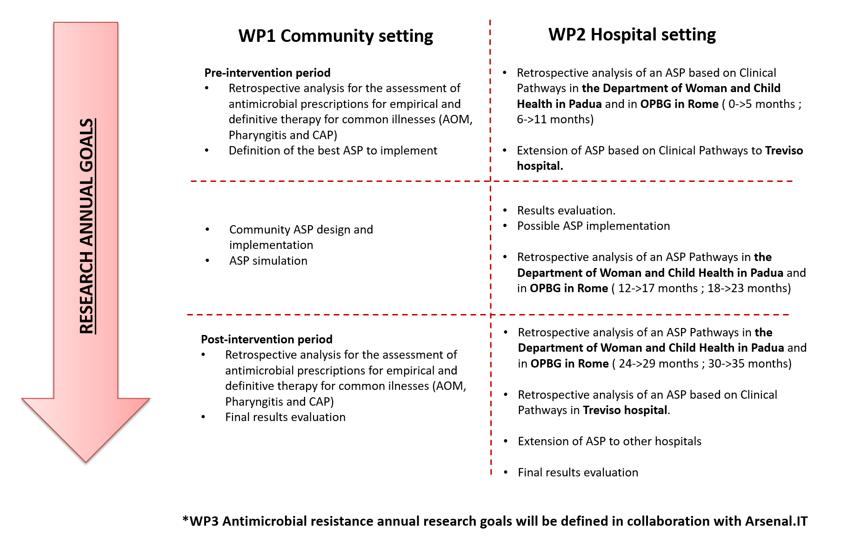
The main objectives of this WP1 are:
- to improve the antibiotic prescription patterns both at community and hospital levels
Hypothesis: Antibiotic Stewardship Policy (ASPs) implementation will reduce the risk of inappropriate prescriptions and will results in a better healthcare for pediatric patients.
- to determine the consumption of antibiotics (in terms of appropriate prophylaxis, empirical and targeted therapy) and compare before and after ASP implementation Hypothesis: ASP implementation will result in an improvement of antibiotic prescriptions in terms of correct first-line therapy choice and treatment duration.
Retrospective analysis
Methods
As detailed above, during the first year of my PhD I performed a retrospective analysis for the assessment of antimicrobial prescriptions for empirical and targeted therapy for acute otitis media (AOM) and Pharyngitis in the community setting..
Data source
The study is a secondary data analysis using data from Pedianet Database (http://www.pedianet.it) between January 2010 and December 2015. Pedianet, a pediatric general practice research database, contains reason for accessing healthcare, health status (according to the Guidelines of Health Supervision of the American Academy of Pediatrics), personal details, growth parameters, diagnosis and clinical details (free text or the 9th International Statistical Classification of Diseases and Related Health Problems system (ICD-9) code), prescriptions and outcome data of the children habitually seen by about 125 family pediatricians (FPs) distributed throughout Italy. The data, generated during routine patient care using common software (JuniorBit ®), are anonymized and sent monthly to a centralized database for validation.
The study and the access to the database were approved by the Internal Scientific Committee.
Study population
The study population included children aged 0 months to 14 years with an ICD-9 code or descriptive diagnosis of acute otitis media (381.0, 381.00, 382, 382.0, 382.00), pharyngitis (034.0, 462) or tonsillitis (463). Pharyngitis diagnosis was divided in three groups: streptococcal pharyngitis, non- streptococcal pharyngitis and non-defined pharyngitis. Strep-A rapid test and PCR detection were considered suitable test to identify the bacterial etiology.
The study cohort was then divided in two sets depending on the presence of (i) AOM diagnosis or (ii) pharyngitis or tonsillitis diagnosis.
Specific AOM exclusion criteria were: concomitant infections, ongoing antibiotic therapy, immunodeficiency or immunosuppressive therapy, tympanostomy tubes at the time of diagnosis, craniofacial abnormalities, chronic otitis media (381.1, 381.2, 381.3, 382.1, 382.2, 382.3), AOM complicated by mastoiditis (383), effusive otitis media, otitis media with catarrh presence, chronic diseases (including cystic fibrosis and diabetes).
Specific pharyngitis exclusion criteria were: concomitant infections, ongoing antibiotic therapy, immunodeficiency or immunosuppressive therapy, previous tonsillectomy (28.2), chronic pharyngitis (472.1), chronic diseases (including cystic fibrosis and diabetes).
Information about the patients, indications and other details of their filled prescriptions, and results of microbial cultures were obtained from the electronic medical files. For patients included in the study, only the first prescription per indication was included.
Statistical analysis
AOM statistical analysis
Prescription distribution was described as the percentage of prescriptions per drug class.
We then defined the frequency rate of prescription according to age (≤6 months, 6-24 months, and >24 months) and trends in the prescriptions of antibiotics over time.
The wait and see approach was defined as treatment beyond 48 hours from the diagnosis.
Pharyngitis statistical analysis
Pharyngitis diagnoses were described according to (i) age (<3 years, ≥3 years), (ii) the test to identify bacterial etiology, and (iii) the results of the test.
Results
We identified 53,529 children followed by 125 family pediatricians between Jan 2010 and Dec 2015. Among them 30,394 had at least an AOM diagnosis and 52,341 a pharyngitis diagnosis. Prescriptions distribution was evaluated considering different groups. The aminoglycosides, as well as all other topical antibiotics were not considered.
AOM diagnosis
Among 30,394 children we recorded 54,943 distinct AOM diagnoses. The mean diagnoses age was 44 months, 2% of these were recorded within 6 months, 22% between 6 and 24 months, and 76% after the 24 months of age.
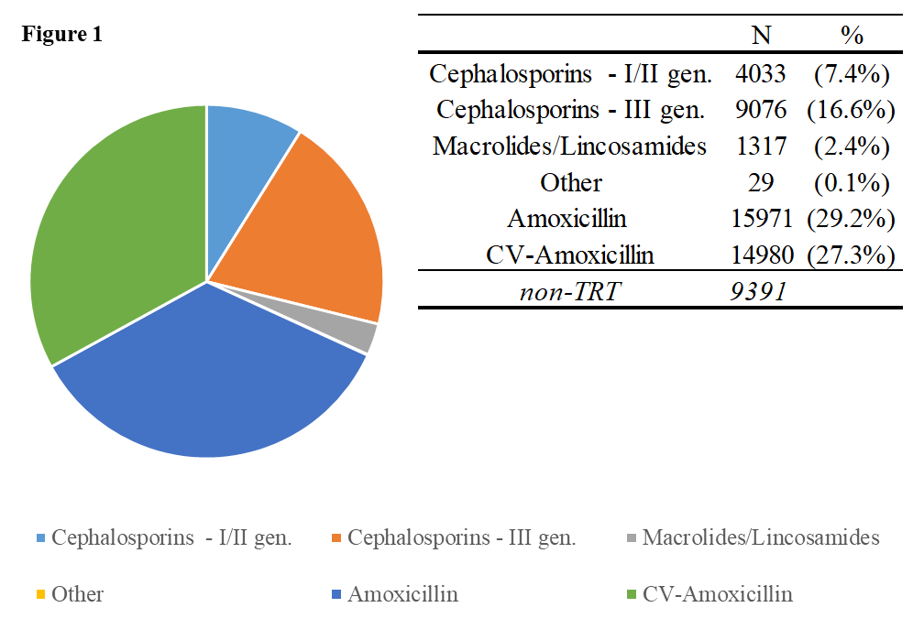
A total of 45,552 (83%) diagnoses were treated within the 48 hours from the diagnosis, and just in the 17% of the cases the ‘wait and see’ approach was. Amoxicillin and CV-Amoxicillin were the classes most frequently prescribed, followed by III generation cephalosporins . The macrolides, as well as the others, were less prescribed with a prescription rate between 0.1% and 2.4% (Figure 1).
The chance to receive a prescription for narrow spectrum antibiotics (amoxicillin, I-II generation cephalosporins) and broad-spectrum antibiotic (CV-Amoxicillin, III generation cephalosporins) is unbalanced towards broad spectrum ones (36.6% vs 43.9%; p<0.05).
Overall there is an increase in broad spectrum prescriptions with the increase of children’s age. More than half of prescriptions for children above 24 months are for broad-spectrum antibiotics. (Figure 2).
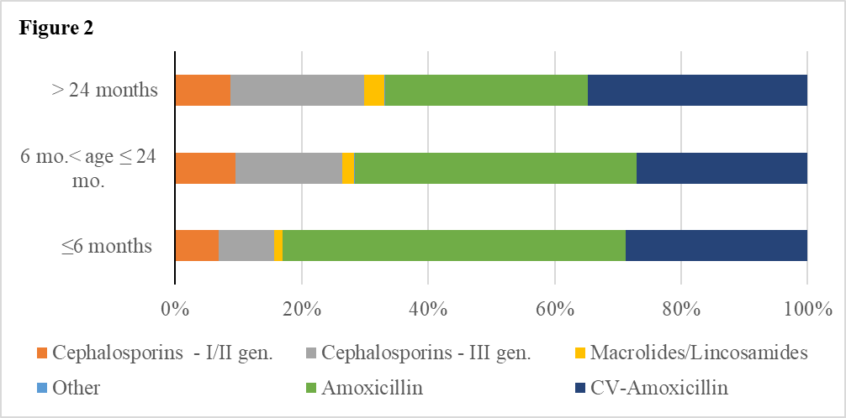
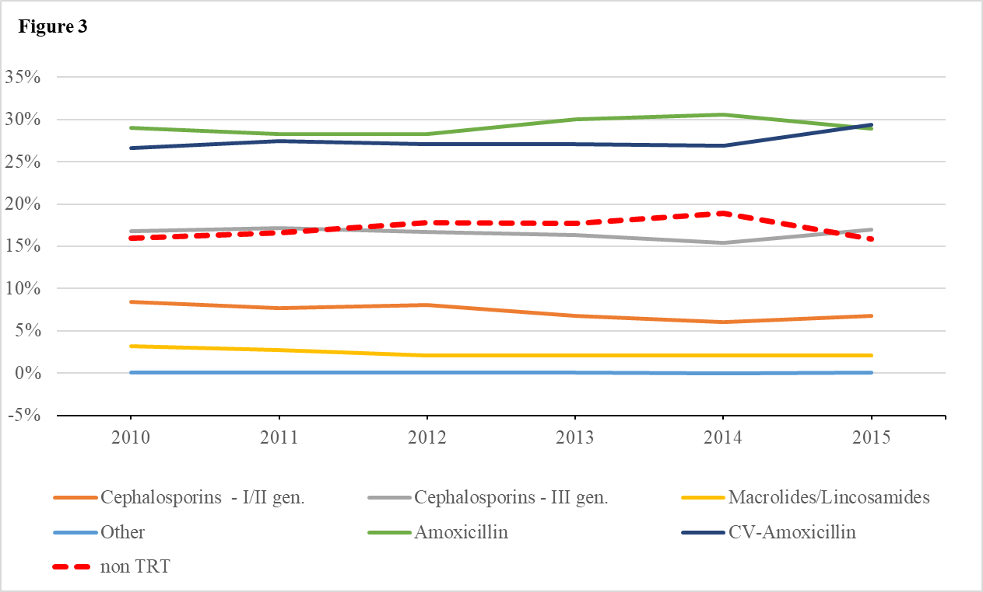
The general trend towards broad-spectrum antibiotic prescription as first line treatment is also reflected in the annual analysis. While amoxicillin prescriptions rate increase till 2014 (30.6%) and then decrease to 28.8% in 2015, CV-Amoxicillin use increased from 26.7% in 2010 to 29.4% in 2015. The frequency of the other antibiotics remained constant over time. The wait and see approach, similarly to amoxicillin treatment, have a maximum point of 18.9% in 2014 with a decrease to 15.8% in 2015 (Figure 3).

Pharyngitis diagnosis
Among 52,341 children were recorded 126,098 distinct pharyngitis or tonsillitis diagnoses. 42% were classified as non-defined pharyngitis, 30% as streptococcal pharyngitis, and 28% as non-streptococcal pharyngitis. The mean age of pharyngitis diagnosis was 5 years (IQ 3-8), the 24% were diagnosed under the three years of age (Table 1).
Table 1.
 | non-defined pharyngitis |  | streptococcal pharyngitis |  | non-streptococcal pharyngitis
 | N | (%) | N | (%) | N | (%)
age <3 yr. | 16612 | (31.4%) | 3925 | (10.46%) | 9589 | (26.9%)
age ≥3 yr. | 36295 | (68.6%) | 33616 | (89.54%) | 26061 | (73.1%)
The number of tests performed changed in accordance with the type of pharyngitis diagnosed as shown in Table 2.
Table 2.
 | non-defined pharyngitis |  | streptococcal pharyngitis |  | non-streptococcal pharyngitis
 | N | (%) | N | (%) | N | (%)
no test | 50019 | (94.54%) | 22189 | (59.11%) | 26923 | (75.52%)
test | 2888 | (5.46%) | 15352 | (40.89%) | 8727 | (24.48%)
test with result | 1923 | (66.59%) | 10123 | (65.94%) | 6074 | (69.6%)
+ | 527 | (27.41%) | 9718 | (96%) | 54 | (0.89%)
- | 1236 | (64.27%) | 193 | (1.91%) | 5986 | (98.55%)
doubt | 160 | (8.32%) | 212 | (2.09%) | 34 | (0.56%)

The pharyngitis diagnostic rapid test was used mostly in streptococcal diagnosis compared to non-streptococcal ones..
Overall, 79,620 (63%) diagnoses were treated with an antibiotic, among which 20% of the non-streptococcal pharyngitis and 43% of the streptococcal pharyngitis (Table 3).
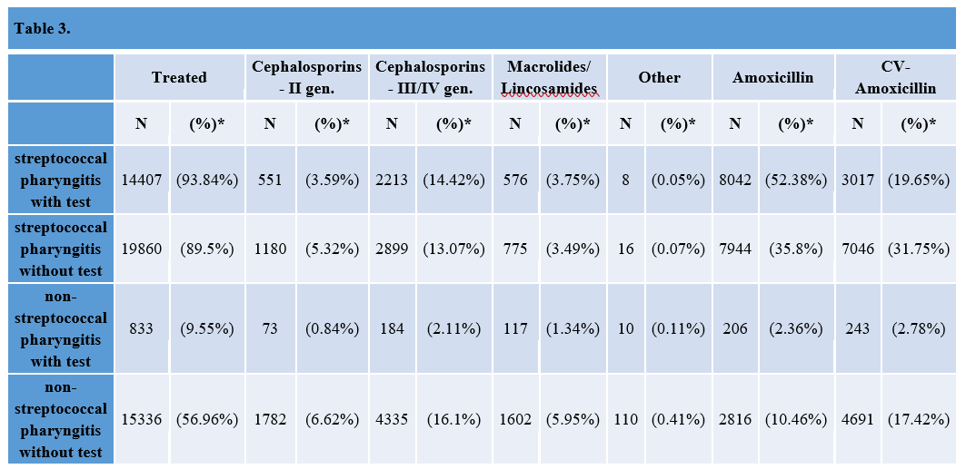
The non-streptococcal pharyngitis diagnosed by microbiological test received less antimicrobial prescriptions than the ones diagnosed with it (56,96 % vs 9,55%). Moreover, most of the prescriptions were broad spectrum antibiotics (CV-Amoxicillin and III/IV gen. cephalosporin). The rate of antibiotic prescriptions for streptococcal pharyngitis did not changed significantly for those made by with or without microbiological test (93,84% vs 89,5%). However, the microbiological confirmation led to an increase of narrow spectrum antibiotic prescriptions (52,58% vs 19,65%).
The chances to have a prescription with III/IV generation cephalosporins was higher with a diagnosis of non-streptococcal pharyngitis not confirmed by microbiological test (16,1% vs 2,11%)..
Conclusion
This analysis shows that the quality of antibiotic prescriptions for pharyngitis is better if the bacterial diagnosis is confirmed by the rapid test; thus this tool utilization is widely recommended. Moreover there is a persistence in the different years in broad spectrum antibiotics prescriptions for both pathologies. More national antibiotic stewardship policy interventions, already proven to be effective for in-patient children, are needed for outpatients.

ASP review and identification of a suitable ASP for pediatric outpatient
A systematic review was performed on ASP implementation in pediatric settings to identify the best ASP to implement after WP1 data collection (Attachment 1).
PubMed and Cochrane Library were searched to identify all papers on ASP intervention in children aged 0-18 years both in-hospital and outpatient settings.
Of the 6435 studies screened, 80 were eligible for inclusion in this study. Most of the studies originated in the US (63.7%), while a minority originated in Europe (12,5%).
Forty-eight (60%) studies used a before-and-after design, and only ten (12.5%) were randomized trials. The vast majority (86.25%) described in-hospital ASPs; half of the interventions involved mixed pediatric wards and six (7.5%) studies were performed in emergency departments.
Ten papers describe ASP in an outpatient setting, among which three are focused on education combined with audit and feedback, three are based on clinical decision support integrated in the electronic health record, two describe just guidelines distribution, one discuss an audit-and-feedback approach, and one describes guideline definition with prediction rule score (Table 4).
Setting | Number of studies | Country | Study intervention
Outpatients | 10 | 6/10 US  1/10 Benin  1/10 Argentina  1/10 Saudi Arabia  1/10 Switzerland | 3/10 Clinical Decision Support tool  3/10 Audit and Feedback + Education  2/10 Guidelines  1/10 Audit and Feedback  1/10 Prediction rule score
Table 4
None of the 10 studies are set in Italy and because of the diversity of healthcare systems considered in the review a wide range of approaches to the same problem could be considered as suitable to be implemented.
In our systematic review, we found that most studies reported just a single intervention, despite the fact that the implementation of two core strategies is strongly recommended by the ASP guidelines; on the other hand these guidelines published so far (IDSA/SHEA) are designed for the US healthcare system and easily adopted in this setting. The setting we would like to implement the ASP is different both in patient population both in specialist availability.
ASPs implemented in outpatient settings, mainly involving audit and feedback + education and the use of computerized decision-support tools, seemed effective in reducing antimicrobial prescriptions especially broad spectrum ones and consequently increasing narrow spectrum prescriptions.
One of the main concerns regarding planning an ASP intervention is physicians compliance to the intervention and the willingness to change they prescription behavior; more than half of the studies analyzed were randomized trials thus the results might not represent perfectly the real situation.
In order to develop a valid intervention that will both achieve adequate prescriptions improvement and meet pediatricians compliance, the Family Pediatrician Society in the Veneto region will be involved in the project. It is of a particular importance to understand the setting where the intervention will be planned and the possible barriers that may obstacle its duration.
Considering the result effectiveness of CPs introduced to Pediatric Emergency Department of Padua combined with yearly education and results presentation (that could be fairly compared to audit and feedback approach), it seems to be a very good point to start with this approach in the outpatient setting.
During the second year, the intervention will be planned and adopted.

Current and future research
Automatic identification of AOM and pharyngitis diagnosis
Diagnosis information for the retrospective analysis were identified by analyzing ICD-9 code or free text in the primary diagnosis field. We used some key words to include or exclude the different observations, but we did not take into consideration the clinical diary field. This free text field could be used by the pediatrician to include some clinical symptoms, as well as other diagnosis.
As well known, data extraction from free text for disease detection at the individual level can be based on manual, in-depth examinations of individual medical records, but it is as precise as time consuming. One option to contain costs and ensure both time-tightening and control is to detect the diagnosis by automatic coding. Machine learning techniques (MLTs) are the most commonly used approaches that show good overall performance. In recent years, these techniques have been largely used for text mining of electronic health records, but transforming this large amount of healthcare data into knowledge is challenging.
As far as now, no algorithm for the identification of otitis or pharyngitis has been published (in Italian language). Thus a further step in my research will be developing an algorithm for the identification of this two diagnosis (if possible) with the collaboration of the Unit of Biostatistics, Epidemiology and Public Health in the Department of Cardiac, Thoracic, Vascular Sciences and Public Health (University of Padua) supervised by Professor Gregori.
The first step (already finished at the end of August 2018) was to create manually the gold standard to identify acute otitis media diagnosis; data on sex, age, pediatrician id-number, patient id-number, day of visit, time of visit, diagnosis, symptoms, test analysis, test result, prescription diagnosis and diaries from January 2004 to August 2017 from Pedianet Database were collected and considered together at the individual level.
Data were then divided in different datasets based on year of visit and pediatrician id-number and classified manually; 0 was assigned to non-case and 1 to AOM case. The idea was to identify at least one case per pediatrician per year in order to account the individual variability but not to make this process extremely time consuming.
After two month of data selection (11.872 observations; year analyzed: from 2004 to 2006 included) it was identified a pattern in the diagnosis identification words. All the positive cases (728 observations) coming from different pediatrician (132 pediatrician) were compared and a string was developed.
The string was built with the aim to include possible typo errors and abbreviations: QWERTY standard keyboard usage was considered.
The string was then applied to the entire dataset and the first ten observation per pediatrician for the first 4 years (4928 observations in total) were then classified accordingly:
0 – non otitis case
1 – otitis case
2 – otitis media case
3 – acute otitis media (AOM) case
4 – AOM with perforation case
5 – recurrent AOM case
Quality control was then performed on 10% of the classified dataset (493 observations) by a pediatrician. Any differences in the classification were resolved by consensus; if was not possible the classification was considered acceptable if the number of observations with a different classification was 9 (less than 2%).
The otitis gold standard was then defined with 4928 observations.
During the first semester of the second year the gold standard will be used to define the data to train, validate and test the machine learning algorithm.
Firstly the text needs to be preprocessed converting it into numbers (computer readable). All fields need to be converted in a text type, the content lowered and cleared it of symbols, punctuation, numbers and extra white spaces. Next, the words need to be stemmed (i.e., reducing them to their basic form, or “root”), which is recognized as one of the most important procedures to perform and constructed 2-gram tokens.
After that, all the (stemmed) stop words (i.e., very common and non-meaningful words, such as articles, conjunctions, etc.) need to be removed from the set of tokens as well as all bigrams containing one of them.
Finally, a Document-Term Matrix (DTM) need to be created as a patient-token matrix, filled by the TF-iDF (Term Frequencies – inverse Document Frequencies) weights.
Boosting will be used as machine learning technique (MLT) : it is a general approach for improving the accuracy of any given learning algorithm. Tuszynski adaptation of the original algorithm will be used ( i.e., LogitBoost ), which is aimed at making the entire process more efficient while applying it on large datasets. The standard boosting technique will be applied to the sequential use of a decision stump classification algorithm as a weak learner (i.e., a single binary decision tree).
Five independent repetitions of 10-fold cross-validation procedure will be performed/considered to validate the MLT on the DTM with the corresponding (by row) “case/non-case” attached labels for training and testing.
The point estimates and 95% Confidence Intervals (95% CI) of Positive Predictive Value (PPV), Negative Predictive Value (NPV), Sensitivity, Specificity, Accuracy and F score as measures of performance will be calculated. PPV is the fraction of positively identified cases that are true positives (often named as “Precision”), while NPV refers to the fraction of positively identified non-cases that are true negatives. Sensitivity is the true positive rate, while Specificity is the true negative rate. Accuracy is the fraction of cases correctly classified, and the F score is the harmonic mean of Sensibility and Specificity.
All the analyses are implemented in the R System with the computing facilities of the Unit of Biostatistics, Epidemiology and Public Health.
WP2 - Hospital setting
Briefly below is summarized the research proposal for WP1 that I presented in January 2018.

The main objectives of this WP2 are:
- to improve the antibiotic prescription patterns both at community and hospital levels
Hypothesis: Antibiotic Stewardship Policy (ASPs) implementation will reduce the risk of inappropriate prescriptions and will results in a better healthcare for pediatric patients.
- to determine the consumption of antibiotics (in terms of appropriate prophylaxis, empirical and targeted therapy) and compare before and after ASP implementation Hypothesis: ASP implementation will result in an improvement of antibiotic prescriptions in terms of correct first-line therapy choice and treatment duration.

- to determine broad-spectrum antimicrobial consumption
Hypothesis: ASP based on pediatric clinical pathways will result in a reduction of broad-spectrum antimicrobial consumption.
Previous research
On October 1, 2015 AOM, Pharyngitis and CAP Clinical Pathways (Attachment 2, 3, 4) were implemented at the Pediatric Emergency Department (PED) of Padua. Three educational lectures were presented in October 2015; these lectures provided PED physicians and residents with an overview of the guidelines, the rationale behind the treatment, and identified situations where local practice diverged from guidelines. Following the lectures, pocket cards were delivered to all participants and, on the same day, by email, to all other attending physicians and resident who were unable to attend. Moreover, CPs posters were distributed across the PED.
Afterwards, data from children diagnosed with AOM, GAS pharyngitis and CAP from 15/10/2014 to 15/04/2015 (pre-intervention period) and from 15/10/2015 to 15/04/2016 and from 15-10-2016 to 15-04-2017 (post-intervention period) were collected. Differences in antibiotic prescription appropriateness, including timing of prescription, breadth of spectrum prescribed, dose, duration of therapy and outcomes were assessed.
These data were used for two doctoral thesis in Medicine (evaluating the effects of CPs for AOM and Pharyngitis in the PED and analyzing the effects of CP for CAP for inpatients and outpatients. Both thesis were published as original research articles to peer-reviewed indexed journals.
Considering the excellent results achieved with CP implementation, such as an increase of proportion of “wait and see” approach for AOM (21,7% pre-intervention vs 33,1% post-intervention), an increase in narrow spectrum antibiotics prescriptions for both AOM (32.0% vs. 51.6%) and pharyngitis (53.6% vs. 93.4%) with a concomitant decrease in broad-spectrum antibiotics prescriptions (68.8% vs 48.4% and 46.4% vs 6.6%), these CPs are still continuously used by pediatricians and new residents were trained to use these tools.

Current and future research
In order to evaluate the long term impact of the Clinical Pathways as ASP tool and the possible differences in terms of applicability in different hospital, two project spin-offs were developed in 2016 in Ospedale Pediatrico Bambino Gesù in Rome and in 2017 in Treviso Ca’ Foncello Hospital.
Moreover, further data were collected from children diagnosed with AOM, pharyngitis and CAP from 15/10/2017 to 15/04/2018 from Padua University Hospital (in the Pediatric Emergency Department (AOM, Pharyngitis and CAP). Another lecture was given in January 2018 to present CPs to new residents and to show the results achieved so far.
A brief time schedule of the intervention and analysis is shown in Figure 4.
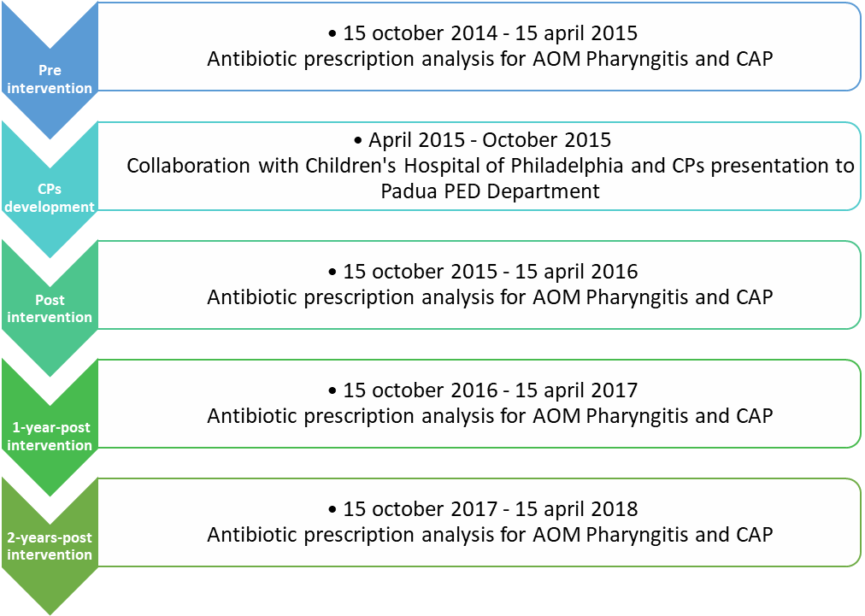
Figure 4
These further analysis are very important to identify eventual barrier in time extension of these ASP and to promptly act in case additional actions such as a second antibiotic stewardship program in support of the actual CPs program might be implemented.
Since a new unplanned part of the WP1 project (automatic identification of AOM and pharyngitis diagnosis) was added this first year, the retrospective statistical analysis and the CPs impact evaluation are three months delayed.
Finally, WP2 spin-off are going to be developed in the second year through other Italian Pediatric Hospitals.
Pharyngitis preliminary results in Padua Hospital
During the 2 year post-intervention period 316 patients evaluated for pharyngitis were included in the study (Figures 5), accounting for the 2.40% (316/13,141) of total PedsED visits. One hundred and thirty-one children were diagnosed with GAS pharyngitis (42,7%; 135/316).
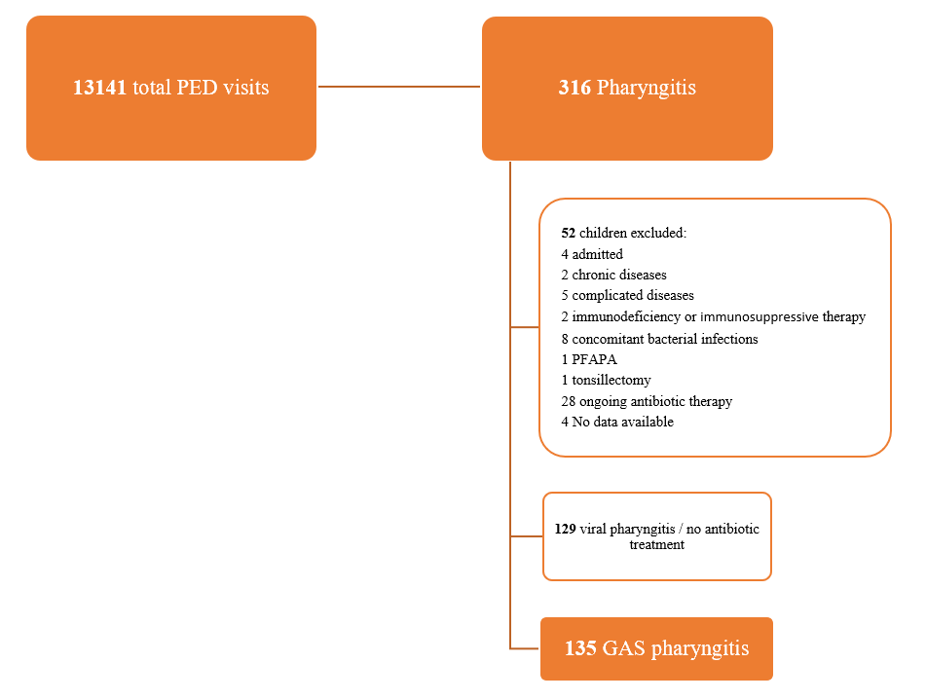
Figure 5.. Flowchart of children enrolled for the study 2 year post-intervention period

Characteristics of study population
The patient included in the 2-year post intervention period groups included in the study were similar to other groups with respect to sex, with a slight male prevalence (51.3%; p=0.56), and age, with prevalence of older children 70.5% (p=0.15) compared with children 2 months-3 years of age that counted of 29.5% visits. Characteristics of the study population are summarized in Table 5.
 | Pre intervention Period |  |  |  | Post intervention Period |  |  |  | 1 year Post intervention Period |  |  |  | 2 year Post intervention Period
Total PedsED visits | 13262 |  |  |  | 12335 |  |  |  | 13082 |  |  |  | 13141
Pharyngitis PedsED visits | 388 (3.0% of total ED visits) |  |  |  | 448 (3.6% of total ED visits) |  |  |  | 417 (3.18% of total ED visits) |  |  |  | 316 (2.40% of total ED visits)
 | Patients excluded |  | Patients included |  | Patients excluded |  | Patients included |  | Patients excluded |  | Patients included |  | Patients excluded |  | Patients included
 | N=90, 23.2% |  | N=298, 76.8% |  | N=82, 18.3% |  | N=366, 81.7% |  | N=91, 21.8% |  | N=326, 78.2% |  | N=52, 16.5% |  | N=264 83.5%
 | N | % | N | % | N | % | N | % | N | % | N | % | N | % | N | %
Male | 58 | 64.4 | 168 | 56.4 | 42 | 51.2 | 214 | 58.5 | 54 | 59.3 | 172 | 52.8 | 30 | 57.7 | 134 | 51.3
Age
2 mo – 3 yr | 31 | 34.4 | 108 | 36.2 | 32 | 39.0 | 146 | 39.9 | 34 | 37.3 | 87 | 26.7 | 15 | 28.8 | 77 | 29.5
3 yr – 15 yr | 59 | 65.6 | 190 | 63.8 | 50 | 61.0 | 220 | 60.1 | 57 | 62.7 | 239 | 73.7 | 37 | 71.2 | 184 | 70.5
Table 5. Characteristics of Study Population
Antimicrobial prescription rate for pharymgitis and complete statistical analysis for AOM and CAP will be completed during the first semester of the second year.

Other curricular activities
Seminars partecipation:
- Oct 2017 : European Clinical Trial Day, the future of clinical research: is the 536/14 regulation enough? (Milan)
- Jan 2018 : I° CORSO IL COORDINATORE DI RICERCA CLINICA IN PEDIATRIA (Padua)
- May 2018: Machine learning in clinical research (predictive models and phenomapping) (Padua)
- May 2018 Antiviral therapy in paediatrics 2018 (Bologna)

Full time courses:
- July 2018 : Utrecht University summer school participation (3 week full time courses)
  - Pharmacoepidemiology and Drug Safety (Lecturers: Prof. S. Suissa, Prof. H.G.M. Leufkens, Prof. A. de Boer, Prof. A.C.G., Egberts, Prof. O.H. Klungel, Prof. T.P. van Staa, Dr. H. Gardarsdottir, Dr. F. de Vries; Course director: Prof. dr. O.H. Klungel)
  - Pharmaceutical Policies Analysis (Lecturers: Prof. Dr. Bert Leufkens, Dr. Gilles Forte (WHO), Dr. Aukje Mantel-Teeuwisse and other UU and WHO staff members)
  - Pharmacoeconomics (Lecturers: Dr. A.K. Mantel-Teeuwisse, Dr. Geert Frederix, Dr. Saskia Knies, Dr. Wim Goettsch; Course director: Dr. A.M. Hövels)
Research related activities:
- Feb 2018 : visiting researcher at Milano Bicocca University (Laboratory of Healthcare Research and Pharmacoepidemiology, Department of Statistics and Quantitative Methods) for WP1 statistical analysis supervised by post-doc Dr. Cantarutti
Papers to be submitted
- Antimicrobial stewardship programs in paediatric care: a systematic review (Authors: D. Dona’, M. Daverio, E. Barbieri, R. Lundin,T. Zaoutis, C. Giaquinto & M. Sharland)
- Antibiotic prescriptions in acute otitis media and pharyngitis in italian pediatric outpatient setting (Authors: E. Barbieri, A.Cantarutti, D.Donà et al.)

ATTACHMENT 1
Antimicrobial stewardship programs in paediatric care: a systematic review
D. Dona’, M. Daverio, E. Barbieri, R. Lundin,T. Zaoutis, C. Giaquinto & M. Sharland
Abstract
Background
Antibiotics are the most commonly prescribed drugs among children in hospitals and communities. It has been demonstrated that a great number of these prescriptions are inappropriate or unnecessary. Antibiotic abuse and misuse increase the risk for serious side effects, raises healthcare costs, and contributes significantly to the global emergency of antimicrobial resistance. As a result, the implementation of strategies to improve the appropriateness of antibiotic prescribing has become an urgent public health priority. Antimicrobial stewardship programs (ASPs) are key instruments to tackle this emergency. The primary aim of this systematic review is to summarize the current state of evidence of the effects of ASPs in paediatrics worldwide; our secondary aim is to compare the practice and implementation of ASPs in the US and Europe.
Methods
PubMed and Cochrane Library were systematically searched to identify studies reporting on ASP in children aged 0-18 years and conducted in outpatient or in-hospital settings. Two investigators independently reviewed identified articles for inclusion and extracted relevant data.
Results
Of the 6435 studies screened, 80 were eligible for inclusion in this study. Most of the studies originated in the US (63.7%), while a minority originated in Europe (12,5%). Forty-eight (60%) studies used a before-and-after design, and only ten (12.5%) were randomized trials. The vast majority (86.25%) described in-hospital ASPs; half of the interventions involved mixed paediatric wards; and six (7.5%) studies were performed in emergency departments. Only ten (12.5%) studies were focused on the costs of ASPs.
Conclusions
Paediatric ASPs have a significant impact on the reduction of targeted- and non-targeted antimicrobial use, healthcare costs, and antimicrobial resistance in both inpatient and outpatient settings. Because of this significant impact, paediatric ASPs are spreading rapidly in the US; while their implementation in Europe is still limited. Further efforts in developing paediatric ASPs in Europe and globally are required.
Background
Antimicrobials are the most commonly prescribed drugs, especially in paediatrics^{1–3}.
It has been estimated that 37-61% of hospitalized infants and children receive antibiotics^{4–8} . Moreover, it has been demonstrated that 20% to 50% of prescriptions are unnecessary or inappropriate ^{9–13}; too many children still receive broad-spectrum antibiotics for viral infections or antibiotic courses that are significantly longer than needed^{14–18} .
This unnecessary exposure increases the risk for serious side effects, raises healthcare costs, and contributes significantly to the global emergency of antimicrobial resistance ^{7,19}. Although antimicrobial resistance occurs naturally or can be acquired through gene transfer, antimicrobial misuse promotes the selection of resistant organisms ^{20,21}. The emergence of resistant pathogens and their global spread has rapidly become an major global public health threat that constitutes a substantial burden for patients, prolongs hospital stays, and leads to increases in both mortality as well as healthcare costs ^{22–27}. Indeed, if antibiotic prescribing in adults and children could be reduced, selection and transmission of resistant strains would decrease. This is particularly urgent due to the steady decline in the number of new antibacterial drugs approved over the last few decades on both sides of the Atlantic ^{28,29}.
The World Health Organization and the United Nations at the General Assembly of 2016 identified the development of country-level and institutional antimicrobial stewardship programs (ASPs) as key instruments to tackle this emergency ^{30,31}.
In 2007, the Infectious Disease Society of America (IDSA) formally introduced the concept of the ASP as a set of coordinated interventions designed for improving antimicrobial use (appropriate agent, dose, route of administration, and therapy duration) without compromising patient outcomes ³². The Paediatric Infectious Diseases Committee on Antimicrobial Stewardship has defined the development of ASPs in three different settings: inpatients, special populations (e.g. oncology), and outpatients. Indeed, the characteristics of specific ASPs may vary to best fit the needs of different settings ³³. The primary aim of this systematic review is to summarize the current state of evidence of the effects of ASPs in paediatrics worldwide; our secondary aim is to compare practice and implementation of ASPs in the US and Europe.

Materials and methods

Study design and Search strategy

A systematic review was conducted according to the Preferred Reporting Items for Systematic Reviews and Meta-Analyses (PRISMA) guidelines ³⁴. In conjunction with a medical librarian, we conducted a systematic search of PubMED and Cochrane Library databases, including citations from January 1, 2007, to October 23, 2017 with a strategy combining Medical Subject Heading (MeSH) and free-text terms for ‘children’ AND ‘antimicrobial’ AND ‘stewardship’. The full strategy is provided in the Supporting information.

Inclusion criteria
Studies were eligible for full-text review if they included all of the following: patients younger than 18 years, and studies conducted in outpatient or in-hospital settings. Randomized controlled trials, controlled and non-controlled pre- and post- studies, controlled and non-controlled interrupted time series, and cohort studies were included.

Exclusion criteria
Review articles, case series, letters, notes, conference abstracts, and opinion articles were excluded. Papers on both adults and children where extraction of paediatric data was not possible were also excluded. We excluded studies published in languages other than English and before 2007, because the concept of antimicrobial stewardship (AS) was formally introduced in 2007. We did not include articles about malaria, HIV, and fungal treatments.

Study selection
Title and abstract as well as full-text assessment was conducted independently by two investigators (DD and MD); any differences in opinion regarding study selection and study details were resolved by consensus. Three rounds of article assessment were conducted before selecting the final list for data abstraction. The selection process is summarized in Figure 1.
Data collection
Data were extracted using a standardized data collection form, which summarized information about authors, year of publication, study design, country, study period, setting, multicentric involvement, type of intervention, and main results.

Figure 1. Flowchart of the study selection process
IDENTIFICATION
Records identified through searching on
COCHRANE = 5951
PUBMED = 474
N = 6425

SCREENING

INCLUDED

ELIGIBILITY

Records after duplicates removed
N = 6332
Records screened by title and abstract
N = 6332
Records excluded
N = 6197
< 2007 = 1534
Non English = 422
No abstract available = 23
Not relevant = 4210
Case reports = 8

Full-text reviewed
N = 135
Articles excluded
N = 65
No data or unclear data on clinical outcome = 6
No separate data on children = 5
Not relevant: 31
No pediatric data: 21
No full-text available: 1
Non English: 1

Retrieved from manual reviewing of reference lists
N = 10
Studies included in quantitative synthesis (meta-analysis)
N = 80

Results

Of 6435 title and abstracts, 80 were eligible for inclusion in this study.

Most of the studies (71/80, 88.75%) originated from high income countries (defined according to the World Bank list of economies in June 2018), mainly implemented in the US (51/80, 63.7%). Only 11/80 (13.75%) papers describe the implementation of an ASP in Europe (Greece, The Netherland, Switzerland, Germany, France, Italy, UK) with few other studies performed Asia (Japan, South Korea, Singapore and Saudi Arabia) and America (Argentina and Canada). Four ASP were tested in upper middle income countries (Russia and China), five in lower middle income countries (Bangladesh, Philippines, India, Indonesia and Pakistan) and one in low income country (Benin).

Twenty-four (30%) were multicentric studies: 58.3% (14/24) were set in the US, 25% (6/24) in Europe and the rest in lower-middle/low income countries (4/24).

Authors, year of publication, study design, country, number of subjects enrolled, setting, type of intervention, and main results are summarized in Table 1.

Forty-eight (48/80, 60%) studies used a before-and-after design: 56% (40/71) of the studies set in high income countries used this design (80%, 32/40 in US and 7.5%, 3/40 in Europe) compared to 83.33% (5/6) of the studies set in lower-middle/low income countries. Other AS study design considered were observational studies (3/80, 3.75% from mixed countries), retrospective studies (12/80, 15% in total, 75% from US, 16.6% from Japan and 8.4% from The Netherlands) and prospective studies (6/80, 7.5% in total, 66.6% from US and 33.4% from Europe). Randomized trials represent 12.5% (10/80) of the included studies, all performed in high income countries, mainly in Europe (Switzerland 40%, 4/10 and Italy 10%, 1/10) and America (US 40% and Argentina 10%).

Sixty-nine studies (69/80, 86.25% in total, 63.76% from US and 14.5% from Europe) describe ASP implementation in the hospital setting. Most of these involve all wards in a paediatric hospital (44/80, 55%), while some are focused on specific settings: 11/80 (13.8%) on the neonatal intensive care unit (NICU), 1/80 (1.3 %) on the paediatric intensive care unit (PICU), 2/80 (2.5%) on both NICU and PICU, 6/80 (7.5%) on the emergency department (ED), 2/80 (2.5%) on the oncology ward, and 2/80 (2.5%) on the operating room (OR).

Ten papers (10/80, 12.5% in total, 60% from US and 10% from Switzerland) describe ASP in an outpatient setting, among which three are focused on education combined with audit and feedback, three are based on clinical decision support integrated in the electronic health record, two describe just guidelines distribution, one discusses an audit-and-feedback approach, and one describes guideline definition with prediction rule score.

AS interventions stratified for different settings are summarized in Table 2.

Sixty-six (66/80, 82.5%) studies report as their main outcome changes in antimicrobial prescribing; six studies (all from US) focused on vancomycin use show an average decrease rate of 36%, comparable with meropenem decrease usage reported to be -22,2% and -31%. Also narrow spectrum antibiotic prescribing changes are studied in 6 researches showing an increase in β-lactams (mainly ampicillin) use.

Other primary outcomes analyzed are changes in antimicrobial resistance (8/80, 10% in total, 50% from US, 25% from Japan, 12.5% from India and 12.5% from China), with a decreased of ESBL producers E.Coli and K.Pneumoniae ranging from 17% to 22% and a reduction in P. Aeruginosa carbapenem resistant rate sub sequentially to observed DOT reduction rate.

Finally reduction in healthcare costs (10/80, 12.5%) and improvement in physicians’ compliance with guidelines (11/80, 13.75%) outcomes confirmed the positive trend of clinical and financial results that an antimicrobial stewardship plan implementation could achieve.
Discussion

Main findings
We have performed a systematic review of all published studies reporting on ASPs in the paediatric population in both the outpatient and in-hospital settings. In adult populations, ASP has been proven to reduce inappropriate antimicrobial use and resistance, enhance patient safety, and lower drug costs [35,36,37]. Nevertheless, only eighty studies over the last ten years were performed in paediatric settings, and data about the effect of ASPs in these settings are still limited.

ASPs are mainly based on two core strategies: prospective audit and feedback, which involves interaction and feedback between an infectious disease physician and the prescriber; or formulary restriction and preauthorization requirements for specific agents ^{32,37}. In our systematic review, we found that only 26/80 (32.5%) studies involved audit and feedback, 8/80 involved pre-authorization (10%), and 4/80 involved both (5%); most studies reported just a single intervention, despite the fact that the implementation of these two core strategies is strongly recommended by the ASP guidelines; the implementation of the two strategies is typical in the US. Not surprisingly, only two core interventions were implemented in Europe;^{38,39} more accuracy in dosage and better adherence to guidelines were obtained, together with an overall decrease of length of therapy and days of therapy, especially for cephalosporins and fluoroquinolones. It is interesting to note that in an audit-and-feedback intervention in the adult population in France⁴⁰, it was observed an improvement in antibiotic prescribing despite the quality of discontinuation, the streamlining and descalation of antibiotics had not significantly changed .

According to the IDSA guidelines ASPs should improve antimicrobial use, leading to reductions in antimicrobial resistance, adverse drug events, healthcare costs, and rates of C. difficile infections. The most commonly reported outcome in this review was a change in the prescriping of antimicrobials, with less emphasis on healthcare costs, safety, and resistance³². According to the literature, all the studies we reviewed evaluating antimicrobial consumption showed a significant reduction in prescriptions ^{39,41–99}.

Another outcome reported by twelve papers (15%) we reviewed was an increase in compliance among prescribing physicians ^{58,60,70,80,100–107}; compliance after ASP implementation was high, showing that ASP interventions are generally well tolerated despite theoretical concerns about prescriber opposition ¹⁰⁸.

Furthermore, ten of the included studies (12.5%) quantified cost savings related to the intervention ^{63,70,71,74,91,93,97,109–111}. Decreases in costs were most often due to lower rates of drug administration. However, the cost savings of ASPs should also include the reduction due to the shift from intravenous to oral administration, the reduction in lengths of hospital stays, and reduced rates of infections due to multidrug resistant bacteria ¹¹². For this reason, formal economic studies are also needed in paediatrics to show how ASP implementation impacts all costs, not just the costs of antibiotics.

Interestingly, eight papers (10%) took into consideration changes in antimicrobial resistance as an outcome ^{62,67,70,74,79,83,99,109}. In three cases, no changes were reported, while the other five studies showed an increased susceptibility of the bacteria analyzed. As Tacconelli et al. ¹¹³ strongly advise, microbiological analysis of common bacteria (such as S. aureus, K. pneumoniae, etc.) before and after ASP implementation should be included, as their prevention and control are important potential indicators of a program’s success.

Other more particular settings and interventions were evaluated in the analysis with limited conclusions due to the paucity of literature (just 6.25% of studies were focused on perioperative prophylaxis, 7.5% on Emergency Department (ED), 12.5% on outpatient settings, and 1.25% on parents’ education activities). On the other hand, it is notable that results from the Weddle et al. study⁹⁵ based on education intervention of prescribers in ED, showing a 2% decrease in inappropriate antibiotic prescribing, were coherent with results from a US study based on an adult population (increased consistency of therapy choice from 44.8% to 83%)¹¹⁴. Furthermore, ASPs implemented in outpatient settings (mainly involving guidelines and the use of computerized decision-support tools) seemed effective in reducing antimicrobial prescriptions.

The primary limitation of our study is that only two databases were searched, and not all paediatric stewardship studies may have been identified. In addition, available search indices and methods were limited; unpublished, unreported data and case reports were not included. Moreover, only articles in English were evaluated, to the exclusion of those published in other languages.

Finally, since no MeSH term was provided for antimicrobial stewardship, a wide search-term strategy was used to ensure the retrieval of all studies with an intervention on antimicrobial use, even if the intervention was not explicitly defined as antimicrobial stewardship.

Future research - conclusion
Paediatric ASPs have a significant impact on the antimicrobial use, healthcare costs, and antimicrobial resistance in both inpatient and outpatient settings. Because of this significant impact, paediatric ASPs are spreading rapidly in the US; while their implementation in Europe is still limited. This could be due to the fact that guidelines published so far (IDSA/SHEA) ^{32,37} are designed for the US healthcare system and easily adopted in this setting, while the diversity of healthcare systems throughout Europe implies a wide range of approaches to the same problem. Secondly, across Europe has been found a high variability of funding opportunities and specialists with advance training in paediatrics, resources in US are more easily accessible. Further efforts in developing paediatric ASPs in Europe are required. Actions are needed to improve the collection of surveillance data regarding antibiotics prescriptions and microbial resistance as well as a consensus on the best measure on measuring the volume of antimicrobial consumptions. More coordination, harmonization, and shared information will lead to a more precise effects on healthcare systems, and, as a result, on patient health as well. This is especially important for paediatric patients, as lack of data represents a greater challenge for paediatricians in their daily practice. Political involvement is also necessary, given the impact that these programs will have on large populations ¹¹⁵.

References:
1. van der Meer JW, Gyssens IC. Quality of antimicrobial drug prescription in hospital. Clin Microbiol Infect. 2001;7 Suppl 6:12-15. http://www.ncbi.nlm.nih.gov/pubmed/11990686. Accessed March 8, 2018.
2. Gerber JS, Newland JG, Coffin SE, et al. Variability in Antibiotic Use at Children’s Hospitals. Pediatrics. 2010;126(6):1067-1073. doi:10.1542/peds.2010-1275
3. Ashiru-Oredope D, Kessel A, Hopkins S, et al. Antimicrobial stewardship: English Surveillance Programme for Antimicrobial Utilization and Resistance (ESPAUR). J Antimicrob Chemother. 2013;68(11):2421-2423. doi:10.1093/jac/dkt363
4. Versporten A, Bielicki J, Drapier N, Sharland M, Goossens H, ARPEC project group. The Worldwide Antibiotic Resistance and Prescribing in European Children (ARPEC) point prevalence survey: developing hospital-quality indicators of antibiotic prescribing for children. J Antimicrob Chemother. 2016;71(4):1106-1117. doi:10.1093/jac/dkv418
5. Potocki M, Goette J, Szucs TD, Nadal D. Prospective Survey of AntibioticUtilization in Pediatric Hospitalized Patients to IdentifyTargets for Improvement of Prescription. Infection. 31(6):398-403. doi:10.1007/s15010-003-4130-1
6. Hajdu A, Samodova OV, Carlsson TR, et al. A point prevalence survey of hospital-acquired infections and antimicrobial use in a paediatric hospital in north-western Russia. J Hosp Infect. 2007;66(4):378-384. doi:10.1016/j.jhin.2007.04.018
7. Berild D, Abrahamsen TG, Andresen S, et al. A controlled intervention study to improve antibiotic use in a Russian paediatric hospital. Int J Antimicrob Agents. 2008;31(5):478-483. doi:10.1016/j.ijantimicag.2008.01.009
8. Ang L, Laskar R, Gray JW. A point prevalence study of infection and antimicrobial use at a UK children’s hospital. J Hosp Infect. 2008;68(4):372-374. doi:10.1016/j.jhin.2008.01.030
9. Hulscher ME, Grol RP, van der Meer JW. Antibiotic prescribing in hospitals: a social and behavioural scientific approach. Lancet Infect Dis. 2010;10(3):167-175. doi:10.1016/S1473-3099(10)70027-X
10. Spoorenberg V, Hulscher MEJL, Akkermans RP, Prins JM, Geerlings SE. Appropriate Antibiotic Use for Patients With Urinary Tract Infections Reduces Length of Hospital Stay. Clin Infect Dis. 2014;58(2):164-169. doi:10.1093/cid/cit688
11. Davey P, Marwick CA, Scott CL, et al. Interventions to improve antibiotic prescribing practices for hospital inpatients. Cochrane Database Syst Rev. 2017;2:CD003543. doi:10.1002/14651858.CD003543.pub4
12. Zarb P, Amadeo B, Muller A, et al. Identification of targets for quality improvement in antimicrobial prescribing: the web-based ESAC Point Prevalence Survey 2009. J Antimicrob Chemother. 2011;66(2):443-449. doi:10.1093/jac/dkq430
13. Hecker MT, Aron DC, Patel NP, Lehmann MK, Donskey CJ. Unnecessary Use of Antimicrobials in Hospitalized Patients. Arch Intern Med. 2003;163(8):972. doi:10.1001/archinte.163.8.972
14. Levy ER, Swami S, Dubois SG, Wendt R, Banerjee R. Rates and Appropriateness of Antimicrobial Prescribing at an Academic Children’s Hospital, 2007–2010. Infect Control Hosp Epidemiol. 2012;33(4):346-353. doi:10.1086/664761
15. Nash DR, Harman J, Wald ER, Kelleher KJ. Antibiotic prescribing by primary care physicians for children with upper respiratory tract infections. Arch Pediatr Adolesc Med. 2002;156(11):1114-1119.
16. McCaig LF, Besser RE, Hughes JM. Antimicrobial-Drug Prescription in Ambulatory Care Settings, United States, 1992–2000. Emerg Infect Dis. 2003;9(4):432-437. doi:10.3201/eid0904.020268
17. Porta A, Hsia Y, Doerholt K, et al. Comparing neonatal and paediatric antibiotic prescribing between hospitals: a new algorithm to help international benchmarking. J Antimicrob Chemother. 2012;67(5):1278-1286. doi:10.1093/jac/dks021
18. Esposito S, Blasi F, Allegra L, Principi N, Mowgli Study Group. Use of antimicrobial agents for community-acquired lower respiratory tract infections in hospitalised children. Eur J Clin Microbiol Infect Dis. 2001;20(9):647-650.
19. Shehab N, Patel PR, Srinivasan A, Budnitz DS. Emergency Department Visits for Antibiotic‐Associated Adverse Events. Clin Infect Dis. 2008;47(6):735-743. doi:10.1086/591126
20. Cosgrove SE. The Relationship between Antimicrobial Resistance and Patient Outcomes: Mortality, Length of Hospital Stay, and Health Care Costs. Clin Infect Dis. 2006;42(Supplement_2):S82-S89. doi:10.1086/499406
21. Maragakis LL, Perencevich EN, Cosgrove SE. Clinical and economic burden of antimicrobial resistance. Expert Rev Anti Infect Ther. 2008;6(5):751-763. doi:10.1586/14787210.6.5.751
22. Eliopoulos GM, Cosgrove SE, Carmeli Y. The Impact of Antimicrobial Resistance on Health and Economic Outcomes. Clin Infect Dis. 2003;36(11):1433-1437. doi:10.1086/375081
23. Roberts RR, Hota B, Ahmad I, et al. Hospital and Societal Costs of Antimicrobial‐Resistant Infections in a Chicago Teaching Hospital: Implications for Antibiotic Stewardship. Clin Infect Dis. 2009;49(8):1175-1184. doi:10.1086/605630
24. Evans HL, Lefrak SN, Lyman J, et al. Cost of Gram-negative resistance*. Crit Care Med. 2007;35(1):89-95. doi:10.1097/01.CCM.0000251496.61520.75
25. Spellberg B, Guidos R, Gilbert D, et al. The Epidemic of Antibiotic-Resistant Infections: A Call to Action for the Medical Community from the Infectious Diseases Society of America. Clin Infect Dis. 2008;46(2):155-164. doi:10.1086/524891
26. Kociolek LK, Patel SJ, Zheng X, Todd KM, Shulman ST, Gerding DN. Clinical and Microbiologic Assessment of Cases of Pediatric Community-associated Clostridium difficile Infection Reveals Opportunities for Improved Testing Decisions. Pediatr Infect Dis J. 2016;35(2):157-161. doi:10.1097/INF.0000000000000954
27. Pant C, Deshpande A, Gilroy R, Olyaee M, Donskey CJ. Rising Incidence of Clostridium difficile Related Discharges among Hospitalized Children in the United States. Infect Control Hosp Epidemiol. 2016;37(1):104-106. doi:10.1017/ice.2015.234
28. Mossialos E. Policies and Incentives for Promoting Innovation in Antibiotic Research. European Observatory on Health Systems and Policies; 2010.
29. Boucher HW, Talbot GH, Bradley JS, et al. Bad Bugs, No Drugs: No ESKAPE! An Update from the Infectious Diseases Society of America. Clin Infect Dis. 2009;48(1):1-12. doi:10.1086/595011
30. United Nations. Political Declaration of the High-Level Meeting of the General Assembly on Antimicrobial Resistance.; 2016.
31. World Health Organization. GLOBAL ACTION PLAN ON ANTIMICROBIAL RESISTANCE.; 2015.
32. Dellit TH, Owens RC, McGowan JE, et al. Infectious Diseases Society of America and the Society for Healthcare Epidemiology of America Guidelines for Developing an Institutional Program to Enhance Antimicrobial Stewardship. Clin Infect Dis. 2007;44(2):159-177. doi:10.1086/510393
33. Septimus EJ, Owens RC. Need and Potential of Antimicrobial Stewardship in Community Hospitals. Clin Infect Dis. 2011;53(suppl_1):S8-S14. doi:10.1093/cid/cir363
34. Liberati A, Altman DG, Tetzlaff J, et al. The PRISMA statement for reporting systematic reviews and meta-analyses of studies that evaluate healthcare interventions: explanation and elaboration. BMJ. 2009;339:b2700. doi:10.1136/BMJ.B2700
35. Kaki R, Elligsen M, Walker S, Simor A, Palmay L, Daneman N. Impact of antimicrobial stewardship in critical care: a systematic review. J Antimicrob Chemother. 2011;66(6):1223-1230. doi:10.1093/jac/dkr137
36. Ohl CA, Dodds Ashley ES. Antimicrobial Stewardship Programs in Community Hospitals: The Evidence Base and Case Studies. Clin Infect Dis. 2011;53(suppl_1):S23-S28. doi:10.1093/cid/cir365
37. SHEA. Antimicrobial Stewardship Toolkit - SHEA.
38. Kreitmeyr K, von Both U, Pecar A, Borde JP, Mikolajczyk R, Huebner J. Pediatric antibiotic stewardship: successful interventions to reduce broad-spectrum antibiotic use on general pediatric wards. Infection. 2017;45(4):493-504. doi:10.1007/s15010-017-1009-0
39. Liem TY, Van Den Hoogen A, Rademaker CM, Egberts TC, Fleer A, Krediet TG. Antibiotic weight-watching: slimming down on antibiotic use in a NICU. Acta Paediatr. 2010;99(12):1900-1902. doi:10.1111/j.1651-2227.2010.01957.x
40. Labenne M, Michaut F, Gouyon B, Ferdynus C, Gouyon J-B. A Population-Based Observational Study of Restrictive Guidelines for Antibiotic Therapy in Early-Onset Neonatal Infections. Pediatr Infect Dis J. 2007;26(7):593-599. doi:10.1097/INF.0b013e318068b656
41. Baer G, Baumann P, Buettcher M, et al. Procalcitonin Guidance to Reduce Antibiotic Treatment of Lower Respiratory Tract Infection in Children and Adolescents (ProPAED): A Randomized Controlled Trial. von Seidlein L, ed. PLoS One. 2013;8(8):e68419. doi:10.1371/journal.pone.0068419
42. Esposito S, Tagliabue C, Picciolli I, et al. Procalcitonin measurements for guiding antibiotic treatment in pediatric pneumonia. Respir Med. 2011;105(12):1939-1945. doi:10.1016/j.rmed.2011.09.003
43. Stocker M, Hop WC, van Rossum AM. Neonatal Procalcitonin Intervention Study (NeoPInS): Effect of Procalcitonin-guided decision making on Duration of antibiotic Therapy in suspected neonatal early-onset Sepsis: A multi-centre randomized superiority and non-inferiority Intervention Study. BMC Pediatr. 2010;10(1):89. doi:10.1186/1471-2431-10-89
44. Stocker M, van Herk W, El Helou S, et al. Procalcitonin-guided decision making for duration of antibiotic therapy in neonates with suspected early-onset sepsis: a multicentre, randomised controlled trial (NeoPIns). Lancet (London, England). 2017;390(10097):871-881. doi:10.1016/S0140-6736(17)31444-7
45. Messacar K, Hurst AL, Child J, et al. Clinical impact and provider acceptability of real-time antimicrobial stewardship decision support for rapid diagnostics in children with positive blood culture results. J Pediatric Infect Dis Soc. 2017;6(3):267-274. doi:10.1093/jpids/piw047
46. Yu D, Stach L, Newland JG, Selvarangan R, Goldman J. Integrating a Rapid Diagnostic Test and Antimicrobial Stewardship. Pediatr Infect Dis J. 2016;35(12):1362-1364. doi:10.1097/INF.0000000000001332
47. Dimopoulou A, Kourlaba G, Psarris A, Coffin S, Spoulou V, Zaoutis T. Perioperative antimicrobial prophylaxis in pediatric patients in Greece: Compliance with guidelines and impact of an educational intervention. J Pediatr Surg. 2016;51(8):1307-1311. doi:10.1016/j.jpedsurg.2015.11.017
48. Caruso TJ, Wang E, Schwenk HT, et al. A quality improvement initiative to optimize dosing of surgical antimicrobial prophylaxis. Kurth D, ed. Pediatr Anesth. 2017;27(7):702-710. doi:10.1111/pan.13137
49. Cantey JB, Patel SJ. Antimicrobial Stewardship in the NICU. Infect Dis Clin North Am. 2014;28(2):247-261. doi:10.1016/j.idc.2014.01.005
50. Al-Tawfiq JA, Alawami AH. A multifaceted approach to decrease inappropriate antibiotic use in a pediatric outpatient clinic. Ann Thorac Med. 2017;12(1):51-54. doi:10.4103/1817-1737.197779
51. Bourgeois FC, Linder J, Johnson SA, Co JPT, Fiskio J, Ferris TG. Impact of a Computerized Template on Antibiotic Prescribing for Acute Respiratory Infections in Children and Adolescents. Clin Pediatr (Phila). 2010;49(10):976-983. doi:10.1177/0009922810373649
52. Finkelstein JA, Huang SS, Kleinman K, et al. Impact of a 16-Community Trial to Promote Judicious Antibiotic Use in Massachusetts. Pediatrics. 2008;121(1):e15-e23. doi:10.1542/peds.2007-0819
53. Forrest CB, Fiks AG, Bailey LC, et al. Improving Adherence to Otitis Media Guidelines With Clinical Decision Support and Physician Feedback. Pediatrics. 2013;131(4):e1071-e1081. doi:10.1542/peds.2012-1988
54. Gerber JS, Prasad PA, Fiks AG, et al. Effect of an Outpatient Antimicrobial Stewardship Intervention on Broad-Spectrum Antibiotic Prescribing by Primary Care Pediatricians. JAMA. 2013;309(22):2345. doi:10.1001/jama.2013.6287
55. Hersh AL, Olson J, Stockmann C, et al. Impact of Antimicrobial Stewardship for Pediatric Outpatient Parenteral Antibiotic Therapy. J Pediatric Infect Dis Soc. 2018;7(2):e34-e36. doi:10.1093/jpids/pix038
56. Hürlimann D, Limacher A, Schabel M, et al. Improvement of antibiotic prescription in outpatient care: a cluster-randomized intervention study using a sentinel surveillance network of physicians. J Antimicrob Chemother. 2015;70(2):602-608. doi:10.1093/jac/dku394
57. Mainous AG, Lambourne CA, Nietert PJ. Impact of a clinical decision support system on antibiotic prescribing for acute respiratory infections in primary care: quasi-experimental trial. J Am Med Informatics Assoc. 2013;20(2):317-324. doi:10.1136/amiajnl-2011-000701
58. Osterholt DM, Onikpo F, Lama M, Deming MS, Rowe AK. Improving pneumonia case-management in Benin: a randomized trial of a multi-faceted intervention to support health worker adherence to Integrated Management of Childhood Illness guidelines. Hum Resour Health. 2009;7(1):77. doi:10.1186/1478-4491-7-77
59. Torres FA, Pasarelli I, Cutri A, Ossorio MF, Ferrero F. Impact assessment of a decision rule for using antibiotics in pneumonia: A randomized trial. Pediatr Pulmonol. 2014;49(7):701-706. doi:10.1002/ppul.22849
60. Gill CJ, Mantaring JBV, Macleod WB, et al. Impact of Enhanced Infection Control at 2 Neonatal Intensive Care Units in The Philippines. Clin Infect Dis. 2009;48(1):13-21. doi:10.1086/594120
61. Akter SFU, Heller RD, Smith AJ, Milly AF. Impact of a training intervention on use of antimicrobials in teaching hospitals. J Infect Dev Ctries. 2009;3(6):447-451. http://www.ncbi.nlm.nih.gov/pubmed/19762958. Accessed March 8, 2018.
62. Ambroggio L, Thomson J, Murtagh Kurowski E, et al. Quality Improvement Methods Increase Appropriate Antibiotic Prescribing for Childhood Pneumonia. Pediatrics. 2013;131(5):e1623-e1631. doi:10.1542/peds.2012-2635
63. Aronson PL, Thurm C, Williams DJ, et al. Association of clinical practice guidelines with emergency department management of febrile infants ≤56 days of age. J Hosp Med. 2015;10(6):358-365. doi:10.1002/jhm.2329
64. Chan S, Hossain J, Di Pentima MC. Implications and Impact of Prior Authorization Policy on Vancomycin Use at a Tertiary Pediatric Teaching Hospital. Pediatr Infect Dis J. 2015;34(5):506-508. doi:10.1097/INF.0000000000000615
65. Chiu C-H, Michelow IC, Cronin J, Ringer SA, Ferris TG, Puopolo KM. Effectiveness of a Guideline to Reduce Vancomycin Use in the Neonatal Intensive Care Unit. Pediatr Infect Dis J. 2011;30(4):273-278. doi:10.1097/INF.0b013e3182011d12
66. Dassner AM, Girotto JE. Evaluation of a Second-Sign Process for Antimicrobial Prior Authorization. J Pediatric Infect Dis Soc. 2018;7(2):113-118. doi:10.1093/jpids/pix015
67. Di Pentima MC, Chan S. Impact of Antimicrobial Stewardship Program on Vancomycin Use in a Pediatric Teaching Hospital. Pediatr Infect Dis J. 2010;29(8):707-711. doi:10.1097/INF.0b013e3181d683f8
68. Doyon S, Perreault M, Marquis C, et al. Quantitative evaluation of a clinical intervention aimed at changing prescriber behaviour in response to new guidelines. J Eval Clin Pract. 2009;15(6):1111-1117. doi:10.1111/j.1365-2753.2009.01259.x
69. Gillon J, Xu M, Slaughter J, Di Pentima MC. Vancomycin Use: Room for Improvement Among Hospitalized Children. J Pharm Pract. 2017;30(3):296-299. doi:10.1177/0897190016635478
70. Goldman JL, Lee BR, Hersh AL, et al. Clinical Diagnoses and Antimicrobials Predictive of Pediatric Antimicrobial Stewardship Recommendations: A Program Evaluation. Infect Control Hosp Epidemiol. 2015;36(6):673-680. doi:10.1017/ice.2015.45
71. Gong S, Qiu X, Song Y, et al. Effect of Financially Punished Audit and Feedback in a Pediatric Setting in China, within an Antimicrobial Stewardship Program, and as Part of an International Accreditation Process. Front Public Heal. 2016;4:99. doi:10.3389/fpubh.2016.00099
72. Hersh AL, De Lurgio SA, Thurm C, et al. Antimicrobial Stewardship Programs in Freestanding Children’s Hospitals. Pediatrics. 2015;135(1):33-39. doi:10.1542/peds.2014-2579
73. Holzmann-Pazgal G, Khan AM, Northrup TF, Domonoske C, Eichenwald EC. Decreasing vancomycin utilization in a neonatal intensive care unit. Am J Infect Control. 2015;43(11):1255-1257. doi:10.1016/j.ajic.2015.06.028
74. Horikoshi Y, Higuchi H, Suwa J, Isogai M, Shoji T, Ito K. Impact of computerized pre-authorization of broad spectrum antibiotics in Pseudomonas aeruginosa at a children’s hospital in Japan. J Infect Chemother. 2016;22(8):532-535. doi:10.1016/j.jiac.2016.05.001
75. Horikoshi Y, Kaneko T, Morikawa Y, et al. The North Wind and the Sun. Pediatr Infect Dis J. 2018;37(2):164-168. doi:10.1097/INF.0000000000001746
76. Hurst AL, Child J, Pearce K, Palmer C, Todd JK, Parker SK. Handshake Stewardship. Pediatr Infect Dis J. 2016;35(10):1104-1110. doi:10.1097/INF.0000000000001245
77. Lee KR, Bagga B, Arnold SR. Reduction of Broad-Spectrum Antimicrobial Use in a Tertiary Children’s Hospital Post Antimicrobial Stewardship Program Guideline Implementation*. Pediatr Crit Care Med. 2016;17(3):187-193. doi:10.1097/PCC.0000000000000615
78. Lee J, Pai H, Kim YK, et al. Control of extended-spectrum β-lactamase-producing Escherichia coli and Klebsiella pneumoniae in a children’s hospital by changing antimicrobial agent usage policy. J Antimicrob Chemother. 2007;60(3):629-637. doi:10.1093/jac/dkm225
79. Lighter-Fisher J, Desai S, Stachel A, Pham VP, Klejmont L, Dubrovskaya Y. Implementing an Inpatient Pediatric Prospective Audit and Feedback Antimicrobial Stewardship Program Within a Larger Medical Center. Hosp Pediatr. 2017;7(9):516-522. doi:10.1542/hpeds.2016-0144
80. McCulloh RJ, Queen MA, Lee B, et al. Clinical Impact of an Antimicrobial Stewardship Program on Pediatric Hospitalist Practice, a 5-Year Retrospective Analysis. Hosp Pediatr. 2015;5(10):520-527. doi:10.1542/hpeds.2014-0250
81. Metjian TA, Prasad PA, Kogon A, Coffin SE, Zaoutis TE. Evaluation of an Antimicrobial Stewardship Program at a Pediatric Teaching Hospital. Pediatr Infect Dis J. 2008;PAP(2):106-111. doi:10.1097/INF.0b013e318158603a
82. Money N, Newman J, Demissie S, Roth P, Blau J. Anti-microbial stewardship: antibiotic use in well-appearing term neonates born to mothers with chorioamnionitis. J Perinatol. 2017;37(12):1304-1309. doi:10.1038/jp.2017.137
83. Murki S, Jonnala S, Mohammed F, Reddy A. Restriction of cephalosporins and control of extended spectrum beta-lactamase producing gram negative bacteria in a neonatal intensive care unit. Indian Pediatr. 2010;47(9):785-788.
84. Murni IK, Duke T, Kinney S, Daley AJ, Soenarto Y. Reducing hospital-acquired infections and improving the rational use of antibiotics in a developing country: an effectiveness study. Arch Dis Child. 2015;100(5):454-459. doi:10.1136/archdischild-2014-307297
85. Newland JG, Stach LM, De Lurgio SA, et al. Impact of a Prospective-Audit-With-Feedback Antimicrobial Stewardship Program at a Children’s Hospital. J Pediatric Infect Dis Soc. 2012;1(3):179-186. doi:10.1093/jpids/pis054
86. Newman RE, Hedican EB, Herigon JC, Williams DD, Williams AR, Newland JG. Impact of a Guideline on Management of Children Hospitalized With Community-Acquired Pneumonia. Pediatrics. 2012;129(3):e597-e604. doi:10.1542/peds.2011-1533
87. Nguyen-Ha P-T, Howrie D, Crowley K, et al. A Quality Assessment of a Collaborative Model of a Pediatric Antimicrobial Stewardship Program. Pediatrics. 2016;137(5):e20150316. doi:10.1542/peds.2015-0316
88. Nzegwu NI, Rychalsky MR, Nallu LA, et al. Implementation of an Antimicrobial Stewardship Program in a Neonatal Intensive Care Unit. Infect Control Hosp Epidemiol. 2017;38(10):1137-1143. doi:10.1017/ice.2017.151
89. Rutman L, Wright DR, OʼCallaghan J, et al. A Comprehensive Approach to Pediatric Pneumonia. J Healthc Qual. 2017;39(4):e59-e69. doi:10.1097/JHQ.0000000000000048
90. Saha D, Patel J, Buckingham D, Thornton D, Barber T, Watson JR. Urine Culture Follow-up and Antimicrobial Stewardship in a Pediatric Urgent Care Network. Pediatrics. 2017;139(4):e20162103. doi:10.1542/peds.2016-2103
91. Seah XFV, Ong YLR, Tan SW, et al. Impact of an Antimicrobial Stewardship Program on the Use of Carbapenems in a Tertiary Women’s and Children’s Hospital, Singapore. Pharmacother J Hum Pharmacol Drug Ther. 2014;34(11):1141-1150. doi:10.1002/phar.1490
92. Smith MJ, Kong M, Cambon A, Woods CR. Effectiveness of Antimicrobial Guidelines for Community-Acquired Pneumonia in Children. Pediatrics. 2012;129(5):e1326-e1333. doi:10.1542/peds.2011-2412
93. Turner RB, Valcarlos E, Loeffler AM, Gilbert M, Chan D. Impact of an Antimicrobial Stewardship Program on Antibiotic Use at a Nonfreestanding Children’s Hospital. J Pediatric Infect Dis Soc. 2017;6(3):piw059. doi:10.1093/jpids/piw059
94. Wattier RL, Levy ER, Sabnis AJ, Dvorak CC, Auerbach AD. Reducing Second Gram-Negative Antibiotic Therapy on Pediatric Oncology and Hematopoietic Stem Cell Transplantation Services. Infect Control Hosp Epidemiol. 2017;38(9):1039-1047. doi:10.1017/ice.2017.118
95. Weddle G, Goldman J, Myers A, Newland J. Impact of an Educational Intervention to Improve Antibiotic Prescribing for Nurse Practitioners in a Pediatric Urgent Care Center. J Pediatr Heal Care. 2013;31(2):184-188. doi:10.1016/j.pedhc.2016.07.005
96. Willis ZI, Gillon J, Xu M, Slaughter JC, Di Pentima MC. Reducing Antimicrobial Use in an Academic Pediatric Institution: Evaluation of the Effectiveness of a Prospective Audit With Real-Time Feedback. J Pediatric Infect Dis Soc. 2016;6(4):piw054. doi:10.1093/jpids/piw054
97. Agwu AL, Lee CKK, Jain SK, et al. A World Wide Web–Based Antimicrobial Stewardship Program Improves Efficiency, Communication, and User Satisfaction and Reduces Cost in a Tertiary Care Pediatric Medical Center. Clin Infect Dis. 2008;47(6):747-753. doi:10.1086/591133
98. Di Pentima MC, Chan S, Hossain J. Benefits of a Pediatric Antimicrobial Stewardship Program at a Children’s Hospital. Pediatrics. 2011;128(6):1062-1070. doi:10.1542/peds.2010-3589
99. Ding H, Yang Y, Wei J, et al. Influencing the use of antibiotics in a Chinese pediatric intensive care unit. Pharm World Sci. 2008;30(6):787-793. doi:10.1007/s11096-008-9220-9
100. Putnam LR, Chang CM, Rogers NB, et al. Adherence to surgical antibiotic prophylaxis remains a challenge despite multifaceted interventions. Surgery. 2015;158(2):413-419. doi:10.1016/j.surg.2015.04.013
101. Geurts DHF, Vos W, Moll HA, Oostenbrink R. Impact analysis of an evidence-based guideline on diagnosis of urinary tract infection in infants and young children with unexplained fever. Eur J Pediatr. 2014;173(4):463-468. doi:10.1007/s00431-013-2182-5
102. Hum RS, Cato K, Sheehan B, et al. Developing Clinical Decision Support within a Commercial Electronic Health Record System to Improve Antimicrobial Prescribing in the Neonatal ICU. Appl Clin Inform. 2014;5(2):368-387. doi:10.4338/ACI-2013-09-RA-0069
103. Messacar K, Campbell K, Pearce K, et al. A Handshake From Antimicrobial Stewardship Opens Doors for Infectious Disease Consultations. Clin Infect Dis. 2017;64(10):1449-1452. doi:10.1093/cid/cix139
104. Miloslavsky M, Galler MF, Moawad I, Actis J, Cummings BM, El Saleeby CM. The Impact of Pediatric-Specific Vancomycin Dosing Guidelines: A Quality Improvement Initiative. Pediatrics. 2017;139(6):e20162423. doi:10.1542/peds.2016-2423
105. Noorani QA, Qazi SA, Rasmussen ZA, Muhammad Y. Use of a pneumonia management tool to manage children with pneumonia at the first level health care facilities. J Pak Med Assoc. 2011;61(5):481-485.
106. Powell SL, Liebelt E. Appropriate Use of Vancomycin in a Pediatric Emergency Department Through the Use of a Standardized Electronic Guideline. J Pediatr Nurs. 2015;30(3):494-497. doi:10.1016/j.pedn.2014.12.014
107. Webber EC, Warhurst HM, Smith SS, Cox EG, Crumby AS, Nichols KR. Conversion of a single-facility pediatric antimicrobial stewardship program to multi-facility application with computerized provider order entry and clinical decision support. Appl Clin Inform. 2013;4(4):556-568. doi:10.4338/ACI-2013-07-RA-0054
108. Stach LM, Hedican EB, Herigon JC, Jackson MA, Newland JG. Clinicians’ Attitudes Towards an Antimicrobial Stewardship Program at a Children’s Hospital. J Pediatric Infect Dis Soc. 2012;1(3):190-197. doi:10.1093/jpids/pis045
109. Horikoshi Y, Suwa J, Higuchi H, et al. Sustained pediatric antimicrobial stewardship program with consultation to infectious diseases reduced carbapenem resistance and infection-related mortality. Int J Infect Dis. 2017;64:69-73. doi:10.1016/j.ijid.2017.09.012
110. Parker SK, Hurst AL, Thurm C, et al. Anti-infective Acquisition Costs for a Stewardship Program: Getting to the Bottom Line. Clin Infect Dis. 2017;65(10):1632-1637. doi:10.1093/cid/cix631
111. Sick AC, Lehmann CU, Tamma PD, Lee CKK, Agwu AL. Sustained Savings from a Longitudinal Cost Analysis of an Internet-Based Preapproval Antimicrobial Stewardship Program. Infect Control Hosp Epidemiol. 2013;34(6):573-580. doi:10.1086/670625
112. Nagel JL, Stevenson JG, Eiland EH, Kaye KS. Demonstrating the Value of Antimicrobial Stewardship Programs to Hospital Administrators. Clin Infect Dis. 2014;59(suppl_3):S146-S153. doi:10.1093/cid/ciu566
113. Tacconelli E, Sifakis F, Harbarth S, et al. Surveillance for control of antimicrobial resistance. Lancet Infect Dis. 2018;18(3):e99-e106. doi:10.1016/S1473-3099(17)30485-1
114. Percival KM, Valenti KM, Schmittling SE, Strader BD, Lopez RR, Bergman SJ. Impact of an antimicrobial stewardship intervention on urinary tract infection treatment in the ED. Am J Emerg Med. 2015;33(9):1129-1133. doi:10.1016/j.ajem.2015.04.067
115. Tacconelli E, Cataldo MA, Paul M, et al. STROBE-AMS: recommendations to optimise reporting of epidemiological studies on antimicrobial resistance and informing improvement in antimicrobial stewardship. BMJ Open. 2016;6(2):e010134. doi:10.1136/bmjopen-2015-010134
116. Patel SJ, Rosen E, Zaoutis T, Prasad P, Saiman L. Neonatologists’ Perceptions of Antimicrobial Resistance and Stewardship in Neonatal Intensive Care Units. Infect Control Hosp Epidemiol. 2010;31(12):1298-1300. doi:10.1086/657334
117. Cantey JB, Wozniak PS, Pruszynski JE, Sánchez PJ. Reducing unnecessary antibiotic use in the neonatal intensive care unit (SCOUT): a prospective interrupted time-series study. Lancet Infect Dis. 2016;16(10):1178-1184. doi:10.1016/S1473-3099(16)30205-5
118. Di Pentima MC, Chan S, Eppes SC, Klein JD. Antimicrobial Prescription Errors in Hospitalized Children: Role of Antimicrobial Stewardship Program in Detection and Intervention. Clin Pediatr (Phila). 2009;48(5):505-512. doi:10.1177/0009922808330774
119. Dommett R, Geary J, Freeman S, et al. Successful introduction and audit of a step-down oral antibiotic strategy for low risk paediatric febrile neutropaenia in a UK, multicentre, shared care setting. Eur J Cancer. 2009;45(16):2843-2849. doi:10.1016/j.ejca.2009.06.003
120. Malcolmson C, Ng K, Hughes S, et al. Impact of Matrix-Assisted Laser Desorption and Ionization Time-of-Flight and Antimicrobial Stewardship Intervention on Treatment of Bloodstream Infections in Hospitalized Children. J Pediatric Infect Dis Soc. 2016;6(2):piw033. doi:10.1093/jpids/piw033
121. Ross RK, Beus JM, Metjian TA, et al. Safety of Automatic End Dates for Antimicrobial Orders to Facilitate Stewardship. Infect Control Hosp Epidemiol. 2016;37(8):974-978. doi:10.1017/ice.2016.103
122. So JP, Aleem IS, Tsang DS, Matlow AG, Wright JG, SickKids Surgical Site Infection Task Force. Increasing Compliance With an Antibiotic Prophylaxis Guideline to Prevent Pediatric Surgical Site Infection. Ann Surg. 2015;262(2):403-408. doi:10.1097/SLA.0000000000000934
123. Walker S, Datta A, Massoumi RL, Gross ER, Uhing M, Arca MJ. Antibiotic stewardship in the newborn surgical patient: A quality improvement project in the neonatal intensive care unit. Surgery. 2017;162(6):1295-1303. doi:10.1016/j.surg.2017.07.021

Supporting information

Search strategy:

(“Child”[Mesh] OR “Child, preschool”[Mesh] OR “Infant”[Mesh] OR child* OR children OR paediatr* OR pediatr* OR infant* OR infancy OR toddler* OR kid* OR baby OR babies OR neonat*) AND (("Guideline Adherence"[Mesh] OR (guideline*[tw] AND (adher*[tw] OR complian*[tw] OR concordan*[tw] OR according[tw]))) AND ("Anti-Bacterial Agents"[Mesh] OR "Anti-Bacterial Agents" [Pharmacological Action] OR "Antifungal Agents"[Mesh] OR "Antifungal Agents" [Mesh] OR anti-bacterial* OR antibacterial* OR anti-mycobacterial* OR antimycobacterial* OR antibiotic* OR anti-infective OR antifungal OR anti-fungal OR bactericid* OR bacteriocid* OR antimicrobial* OR treatment* OR therap* OR prophyla* OR perioperative* OR stewardship NOT case reports[pt]) NOT ("HIV Infections"[Mesh] OR HIV[Mesh] OR HIV[ti] OR human immunodeficiency virus[ti]))

Author | Study design | Country | Study period | Setting | Multicentric | Interventions | Main results
Agwu et al,  2008 ⁹⁷ | Before and after | US | Jul 2004 - Jun 2005; Jul 2005 - Jun 2006 | Hospital (all wards) | Yes | Pre-authorization | A $370,069 reduction in projected annual cost associated with restricted antimicrobial use and an 11.6% reduction in the number of dispensed doses
Akter et al,  2009⁶¹ | Before and after | Bangladesh | 1998 - 2000 | Hospital (all wards) | Yes | Education | Appropriate antimicrobial therapy for pneumonia and diarrhea increased by 16.4% and 56.8% respectively
Al‐Tawfiq et al,  2017⁵⁰ | Observational | Saudi Arabia | Dec 2012 - Dec 2013 | Outpatient | No | Audit and feedback + Education | The monthly rate of prescription of inappropriate antibiotics significantly decreased from 12.3% to 3.8%
Ambroggio et al,  2013⁶² | Before and after | US | May 2011 - July 2012 | ED and pediatric ward | No | CP | Appropriate first-line antibiotic prescriptions for CAP increased from of 0% to 100% at the ED and on the hospital medicine resident teams from 30% to 100%
Aronson et al,  2015⁶³ | Retrospective | US | 2014 | ED | Yes | Guidelines | Ceftriaxone use at ED discharge varied significantly based on CPG recommendations
Baer et al,  2013⁴¹ | Randomized trial | Switzerland | Jan 2009 - Feb 2010 | ED | Yes | Laboratory (PCT) | Mean duration of antibiotic exposure was reduced from 6.3 to 4.5 days under PCT guidance for all LRTI and from 9.1 to 5.7 days for pneumonia
Berild et al,  2008⁷ | Before and after | Russia | Oct - Dec 2002; Oct - Dec 2003; Oct - Dec 2004 | Two Pediatric wards | No | Guidelines | The percentage of patients with GII who received antibiotics decreased from 94% in 2002 to 41% in 2003, but increased to 73% in 2004. In RTI patients these percentages were 90% in 2002, 53% in 2003 and 83% in 2004
Bourgeois et al,  2010⁵¹ | Randomized trial | US | Oct 2006 - Apr 2007 | Outpatient | Yes | Computerized decision support | Prescriptions for ARI significantly reduced (31.7% vs 39.9%; P = .02) as the use of macrolides (6.2% vs 9.5%; P = .02)
Cantey et al,  2016¹¹⁷ | Observational | US | Oct 2011 - Nov 2012); Oct 2013 - Jun 2014 | NICU | No | A 48h electronic “hard stop” | Antibiotic use declined from 343∙2 days of therapy per 1000 patient-days to 252∙2 days of therapy per 1000 patient-days
Caruso et al,  2017⁴⁸ | Before and after | US | Jan 2012 - Dec 2013; Jan 2014 - Dec 2016; Jan 2016 - May 2016 | Hospital (all wards) | No | Electronic medical record order set + utilization of pharmacists to prepare antibiotic.  (perioperative prophylaxis) | The rate of compliance of administering cefazolin at 30 mg.kg-1 was significantly higher when given after an electronic order than when given verbally, 94% vs 76%
Chan et al,  2015⁶⁴ | Before and after | US | Apr 2001 - Mar 2004; Apr 2004 - Mar 2007 | Hospital (all wards) | No | Audit and feedback | Vancomycin use declined from 378 doses administered/1000 patient-days to 208 doses administered/1000 patient- days (45%). Following the implementation of preauthorization, vancomycin use decreased by an additional 16%
Chiu et al,  2011⁶⁵ | Before and after | US | 6 months 2005-2006; 6 months 2006-2007 | NICU | Yes | Guidelines | Vancomycin start rates were reduced from 6.9 to 4.5 per 1000 patient-days (35% reduction; P <0 .01) at Brigham and Women’s Hospital, and from 17 to 6.4 per 1000 patient-days (62% reduction; P < 0.0001) at Massachusetts General Hospital. The number of infants exposed to vancomycin decreased from 5.2 to 3.1 per 1000 patient-days (40% reduction; P < 0.008) at Brigham and Women’s Hospital, and 10.8 to 5.5 per 1000 patient-days (49% reduction; P < 0.009) at Massachusetts General Hospital. Causes of infection, duration of bacteremia, and incidence of complications or deaths attributable to late-onset infection did not change significantly at either institution
Dassner et al,  2017⁶⁶ | Before and after | US | Jul 2014 - Jun 2015 | Hospital (all wards) | No | Pre-authorization | Appropriateness of second-sign restricted antibiotic use significantly increased (84.5% to 92.9%)
Dimopoulou et al.,  2016⁴⁷ | Before and after | Greece | Apr 2013 - Dec 2014 | Hospital (all wards) | No | Guidelines  (perioperative prophylaxis) | The percentage of patients receiving appropriate perioperative antimicrobial prophylaxis improved from 6.2% to 77.1%
Di Pentima et al,  2009¹¹⁸ | Prospective | US | Apr 2004 - Mar 2005 | Hospital (all wards) | No | Audit and feedback | Errors rate associated with these was 0.09/1000 doses administered and 5 errors/1000 patient days
Di Pentima et al,  2010⁶⁷ | Prospective | US | Apr 2004 - Mar 2007 | Hospital (all wards) | No | Audit and feedback | Density of vancomycin use declined overtime from 378 doses administered/1000 patient-days to 255 doses administered/1000 patient- days. The rate of vancomycin prescription errors decreased
Di Pentima et al,  2011⁹⁸ | Before and after | US | Apr 2004 - Mar 2007 | Hospital (all wards) | No | Audit and feedback | Total antimicrobial use decreased to 1904 doses administered per 1000 patient-days per year. Targeted- antimicrobial use declined from 1250 to 988 doses administered per 1000 patient-days per year. Nontargeted-antimicrobial use declined from 1839 to 916 doses administered per 1000 patient-days per year. Rates of antimicrobial resistance to broad-spectrum antimicrobials among the most common Gram-negative bacilli remained low and stable over time
Ding et al.,  2008⁹⁹ | Before and after | China | Jan 2002 - Dec 2006 | PICU | No | Guidelines + Education + control of antibiotic prescriptions  with the use of a guideline | Reduction in the rate of antibiotic cost/patient/day (P<0.05); a decrease in the prescription rate of third-generation cephalosporins and macrolides (P<0.01); an increase in the prescription rate of b-lactam/b-lactamas inhibitors and second-generation cephalosporins (P<0.01); a reduction in the empiric treatment (P<0.01); and a significant reduction in the incidence rates of bacterial resistance for imipenem-, cefepime-, and ceftazidime-resistant Pseudomonas aeruginosa (P<0.05), and cefepime-resistant Escherichia coli and Klebsiella pneumoniae (P<0.01)
Dommett et al,  2009¹¹⁹ | Prospective | UK | Apr 2004 - Mar 2005) | Oncology | Yes | Guidelines and checklist | Low hospital readmission rate (8/143 episodes; 5.6%), no intensive care admissions and no deaths in LR episodes
Doyon et al,  2009⁶⁸ | Before and after | Canada | Oct 2004 - Mar 2005; Oct 2005 - Jan 2006; Jan 2006 - Mar 2006 | Hospital (all wards) | No | Guidelines | Guidelines compliance increased from 131/652 (20.1%) to 264/499 (52.9%). An inappropriate choice of antibiotic agent decreased from 347/521 (66.6%) to 99/235 (42.1)
Esposito et al.,  2011⁴² | Randomized trial | Italy | Oct 2008 - Sep 2010 | Hospital (all wards) | No | Laboratory (PCT) | The PCT group received significantly fewer antibiotic prescriptions (85.8% vs 100%; p < 0.05), were exposed to antibiotics for a shorter time (5.37 vs 10.96 days; p < 0.05), and experienced fewer antibiotic-related adverse events (3.9% vs 25.2%; p < 0.05), regardless of CAP severity. There was no significant difference in recurrence of respiratory symptoms and new antibiotic prescription in the month following enrollment
Finkelstein et al.,  2008⁵² | Randomized trial | US | Sep 1998 - Mar 2004 | Outpatient | Yes | Audit and feedback + Guideline + Education + Education involving parents | 4.2 % decrease among children aged 24 to <48 months and 6.7% decrease among those aged 48 to <72 months
Forrest et al,  2013⁵³ | Randomized trial | US | Dec 2007 - Sep 2010 | Outpatient | Yes | Computerized decision support | The increase from baseline to intervention periods in adherence to guidelines was larger for CDS compared with non-CDS visits
Gerber et al,  2013⁵⁴ | Randomized trial | US | Oct 2008 - Jun 2011 | Outpatient | Yes | Audit and feedback + Education | Broad-spectrum antibiotic prescribing decreased from 26.8% to 14.3% vs from 28.4% to 22.6% in controls. CAP off-guideline prescribing decreased from 15.7% to 4.2% among intervention practices compared with 17.1% to 16.3% in controls. Acute sinusitis off-guideline prescribing dedcresed from 38.9% to 18.8% in intervention practices and from 40.0% to 33.9% in controls. Off-guideline prescribing was uncommon at baseline and changed little for streptococcal pharyngitis and for viral infections
Geurts et al,  2013¹⁰¹ | Before and after | The Netherlands | Jan 2008 - Jan 2009; Apr 2010 - Apr 2011 | ED | No | Guidelines | Guidelines compliance increased (24.9 % pre vs 46.7 % post)
Gill et al,  2009⁶⁰ | Before and after | Philippines | May 2003 - Aug 2004 | NICU | Yes | Guidelines (simplified package of infection control measures) | Staff hand hygiene compliance improved and overall mortality declined. Colonization with resistant pathogens and sepsis rates did not change significantly at either NICU
Gillon et al,  2017⁶⁹ | Before and after | US | 2009 - 2014 | Hospital (all wards) | No | Audit and feedback | Monthly vancomycin use decreased from 114 DoTs/1000 patient-days to 89 DoTs/1000 patient-days
Goldman et al,  2015⁷⁰ | Retrospective | US | Mar 2008 - Mar 2013 | Hospital (all wards) | No | Audit and feedback | Third-generation cephalosporins, (0.20) were the antimicrobials with the highest predictive probability of an ASP recommendation whereas linezolid (0.05) had the lowest probability
Gong et al,  2016⁷¹ | Before and after | China | Jan 2011 - Apr 2011; May 2011 - Sep 2011; Oct 2011 - Nov 2012 | Hospital (all wards) | No | Pre-authorization + financially punished audit and feedback | The proportion of both antibiotic prescriptions and expenditure on antibiotics dropped immediately
Hersh at al,  2015⁷² | Retrospective | US | 2007 - 2012 | Hospital (all wards) | Yes |  | 8 of 9 ASP+ hospitals revealed declines in antibiotic use, with an average monthly decline in days of therapy/1000 patient-days of 5.7%. For the select subset of antibiotics, the average monthly decline was 8.2%
Hersh et al,  2017⁵⁵ | Before and after | US | May 2013 - Apr 2014; May 2014 - May 2015 | Outpatient | No | Audit and feedback | Introduction of the program was associated with a 24% reduction in OPAT use
Holzmann-Pazgal et al,  2015⁷³ | Before and after | US | Oct 2012 - Apr 2014 | NICU | No | Audit and feedback + Education | Vancomycin utilization and administration duration >3 days significantly decreased but it was not affected by addition of audit and feedback
Horikoshi et al,  2016⁷⁴ | Retrospective | Japan | Mar 2010 - Mar 2015 | Hospital (all wards) | No | Pre-authorization | Administration of carbapenems, piperacillin/tazobactam, and ceftazidime decreased significantly. Antibiotic costs were reduced by 26,000 USD annually. None of the antipseudomonal agents showed decreased sensitivity
Horikoshi et al,  2017¹⁰⁹ | Before and after | Japan | Apr 2010 - Sep 2011; Oct 2011 - Mar 2017 | Hospital (all wards) | No | Pre-authorization + audit and feedback | A positive correlation was observed between the carbapenem resistance rate in Pseudomonas aeruginosa and DOT (0.76, p = 0.04). The carbapenem resistance rate in P. aeruginosa (p < 0.01) and DOT (p < 0.01) decreased significantly
Horikoshi et al,  2018⁷⁵ | Retrospective | Japan | Oct 2011 - Sep 2015 | Hospital (all wards) | No | Pre-authorization + audit and feedback | DOTs of cefepime, piperacillin/tazobactam, meropenem and vancomycin decreased by 20%, 45%, 57% and 38% respectively (p<0.05).
Hum et al,  2014¹⁰² | Prospective | US | Jul 2010 - May 2012 | NICU | Yes | clinical decision support (CDS) tool | Most (63%) survey respondents were aware of the CDS tool, but fewer (37%) used it during their most recent NICU rotation
Hurlimann et al,  2015⁵⁶ | Randomized trial | Switzerland | Jan 2011 - 31 Dec 2012 | Outpatient | Yes | Guidelines | The intervention was less effective in pediatric practices than in general or internal practices
Hurst et al,  2016⁷⁶ | Before and after | US | Oct 2010 - Sep 2014 | Hospital (all wards) | No | Audit and feedback | Overall antimicrobial use decreased by 10.9% during the 4 years of the analysis. Vancomycin use decreased by 25.7%, meropenem by 22.2% without a compensatory increase of other antipseudomonal agents
Kreitmeyr et al,  2017³⁸ | Before and after | Germany | Sep 2014 - Dec 2014; Sep 2015 - Dec 2015 | Hospital (all wards) | No | Audit and feedback | Overall days-of-therapy and length-of-therapy decreased by 10.5 and 7.7%, respectively. Use of cephalosporins and fluoroquinolones decreased by 35.5 and 59.9%, whereas the use of penicillins increased by 15.0%. An increase in dosage accuracy was noted (78.8 vs. 97.6%) and guideline adherence for CAP improved from 39.5 to 93.5%
Labenne et al,  2007⁴⁰ | Prospective | France | Feb 2002 - Jun 2003 | NICU | Yes | Guidelines for EOS | The EONI cure rate was 96.8% without infectious relapse
Lee et al,  2016⁷⁷ | Before and after | US | Sep 2010 - Aug 2011; Sep 2011 - Aug 2012; Sep 2012 - Aug 2013. | Hospital (all wards) | No | Guideline + education | Hospital-wide targeted broad- spectrum antibiotic days of therapy/1,000 patient-days decreased from 33% to 70%. The overall antibiotic days of therapy decreased 41%, 21%, and 18%, and targeted broad-spectrum antibiotic days of therapy decreased by 99%, 75%, and 61% in the cardiac, pediatric, and neonatal ICUs, respectively. Yearly purchases of our most common broad-spectrum antibiotics decreased 62% from $230,059 to $86,887 after guideline implementation. Median monthly purchases of these drugs before implementation were $19,389 and $11,043 after implementation (p < 0.001)
Lee et al,  2007⁷⁸ | Before and after | South Korea | Jan 1999 - Dec 2005 | Hospital (all wards) | No | Pre-authorization | Piperacillin/tazobactam use increased from 2.2 to 108.0 days on antibiotics/1000 patient admission days/year (AD) (P<0.001), whereas extended-spectrum cephalosporin use decreased from 175.0 to 96.9 AD (P<0.001). Among 252 strains of E. coli and K. pneumoniae, the overall prevalence of ESBL producers decreased from 39.8% (41/103) to 22.8% (18/79) (p< 0.018)
Liem et al,  2010³⁹ | Retrospective | The Netherlands | 1990-2008 | NICU | No | Audit and feedback | Total antimicrobial use, expressed as DOT decreased significantly, from 9.0 to 5.8
Lighter-Fisher et al,  2017⁷⁹ | Before and after | US | Jan 2010 - Dec 2011; Jan 2014 - Dec 2015 | Hospital (all wards) | No | Audit and feedback | Total antimicrobial days of therapy and length of therapy decreased significantly. The susceptibility profiles of common bacterial pathogens to antibiotics remained stable
Mainous et al,  2013⁵⁷ | Before and after | US | Oct 2009 - Dec 2009; Jan 2010 - Mar 2011 | Outpatient | Yes | Computerized decision support | Decline of 19.7% in broad-spectrum antibiotic prescriptions versus an increase of 0.9% in control practices
Malcolmson et al,  2016¹²⁰ | Retrospective | US | Oct 2009 - Jul 2010; Oct 2013 - Jul 2014 | Hospital (all wards) | No | Laboratory - MALDI-TOF technology and ASP | Time to optimal therapy reduced (77.0 to 54.2 h). In the subgroup analysis of Gram-negative bacteremia, time to effective and optimal therapy were significantly reduced (2.0 vs 0.7 h and 146.8 vs 48.0 h, respectively)
McCulloh et al,  2015⁸⁰ | Retrospective | US | Mar 2008 - Jun 2013 | Hospital (all wards) | No | Audit and feedback | Ceftriaxone was the most common antibiotic associated with a recommendation (154/350, 44.0%); community-acquired pneumonia was the most common diagnosis (105/350, 30.0%). Disagreement with ASP recommendations was associated with a decreased length of stay of 15.4 (95% confidence interval –33.2 to 1.1) hours but not 30-day readmission prevalence
Messacar et al,  2017⁴⁵ | Before and after | US | Jan 2015 - Mar 2015 | Hospital (all wards) | No | Laboratory - FilmArray blood culture identification panel | The median time to optimal therapy decreased from 60.2 hours to 26.7 hours. Among children with blood cultures that contained true pathogens, the time to effective antimicrobial therapy decreased from 6.9 to 3.4 hours. Unnecessary antibiotic initiation for children with a culture that contained organisms considered to be contaminants decreased from 76% to 26%
Messacar et al,  2017¹⁰³ | Before and after | US | Oct 2010 - Sep 2015 | Hospital (all wards) | No | Audit and feedback | Mean monthly ID consultations per 1000 admissions increased from 31.0 to 42.0
Metjian et al,  2008⁸¹ | Prospective | US | Apr 2005 - Jul 2005 | Hospital(all wards) | No | Pre-authorization + audit and feedback | Forty-five percent of calls required an intervention by the ASP:1) Targeting the known or suspected pathogens (20%); 2) Consultation (43%); 3) Optimize antimicrobial treatment (33%); and 4) Stop antimicrobial treatment (4%)
Miloslavsky et al,  2017¹⁰⁴ | Before and after | US | 2010 - 2013; Jan 2015 - Feb 2016 | Hospital (all wards) | No | Guidelines | The time to therapeutic trough decreased from 2.78 to 1.56 days. Vancomycin-related toxicity was unchanged by the intervention (6.1% versus 4.5%)
Money et al,  2017⁸² | Retrospective | US | 2009 - 2016 | NICU | No | Protocol based on a neonatal early-onset sepsis (EOS) calculator | Antibiotic use decreased from 99% to 2.5%. Average length of therapy decreased from 2.08 to 0.05 days
Murki et al.,  2010⁸³ | Before and after | India | Jan 2007 - Dec 2008 | NICU | No | Cephalosporins restriction policy | Five-fold decrease in the use of cephalosporins and nearly two folds increase in the use of ampicillin and ciprofloxacin. The incidence of ESBL gram negatives decreased by 22% (47% to 25%). Cefotaxime and ciprofloxacin resistance decreased (cefotaxime 81% vs 51%; ciprofloxacin 56%% vs 29%)
Murni et al,  2015⁸⁴ | Before and after | Indonesia | Dec 2010 - Nov 2011; Dec 2011 - Feb 2012; Mar 2012 - Feb 2013 | PICU and Pediatric wards | No | Guidelines + Infection control practices implementation | Major reduction in HAIs, from 22.6% to 8.6%. Inappropriate antibiotic use declined from 43% to 20.6%. Hand hygiene compliance increased from 18.9% to 62.9%. In-hospital mortality decreased from 10.4% to 8%
Newland et al,  2012⁸⁵ | Before and after | US | Mar 2008 - Dec 2010 | Hospital (all wards) | No | Audit and feedback | Antibiotic use decreased from 883 DoT and 567 LoT per 1000 patient-days to 787 DoT and 523 LoT per 1000 patientdays. Select antibiotics dropped from 353 DoT and 294 LoT per 1000 patient-days to 311 DoT and 256 LoT per 1000 patient days. Antibiotic monthly usage was 6% less for both DoT and LoT per 1000 patient-days
Newman et al,  2012⁸⁶ | Before and after | US | Jul 2007 - Jul 2009 | Hospital (all wards) | No | Audit and feedback + Guidelines | 34% increase in ampicillin use. Discharge antibiotics also changed, significant increase in amoxicillin and a significant decrease in cefdinir and amoxicillin/clavulanate
Nguyen-Ha et al,  2016⁸⁷ | Before and after | US | first quarter 2008 - third quarter 2013 | Hospital (all wards) | No | Audit and feedback + Guidelines | Blunting of a significant downward trend for vancomycin drug starts (relative change –12%) and use (–25%). Although meropenem use was already low due to preexisting requirements for preauthorization, a decline in drug use (–31%, P = .021) and a nonsignificant decline in drug starts (–21%, P = .067) were noted
Noorani et al,  2011¹⁰⁵ | Observational | North Pakistan | Oct 2000 - Apr 2001 | Hospital (all wards) | Yes | Guidelines | Health workers adherence improved from 14% to 29% after training and 65% with on the job support
Nzegwu et al,  2017⁸⁸ | Quasi-experimental, interrupted time-series study | US | Jan 2011 - Jun 2016 | NICU | No | Audit and feedback | Antibiotic use decreased by 14.7 DOT per 1,000 patient days. Ampicillin use, decreased significantly, declining by 22.5 DOT per 1,000 patient days. Late-onset sepsis per 100 NICU days of clinical service decreased significantly, with an average reduction of 2.65 evaluations per year per provider
Osterholt et al,  2009⁵⁸ | Before and after | Africa (Benin) | 1999, 2001, 2002, 2004 | Outpatient | Yes | Guideline + supervision | Per-protocol analyses suggested that health workers with training plus study supports performed better than those with training plus usual supports (20.4 and 19.2 percentage-point improvements for recommended treatment [p = 0.08] and "recommended or adequate" treatment [p = 0.01], respectively).
Parker et al,  2017¹¹⁰ | Retrospective | US | Oct 2010 - Sep 2014 | Hospital (all wards) | No | Audit and feedback | Pharmacy purchasing endorsed minimal financial benefit (decrease planning to post-ASP of $590 dollars per 1000 patient-days), EMR and PHIS data endorsed a decrease of $12 785 and $21 380 per 1000 patient-days, respectively, for a total yearly cost savings of $54 656 for pharmacy purchasing data, $1 184 336 for EMR data, and $2 117 522 for PHIS data
Powell et al,  2015¹⁰⁶ | Before and after | US | Jan 2009 - May 2012 | ED | No | Guidelines + order template + individual chart audits | No statistical difference in utilization rates pre- and post-STGOT (4% vs 3%).
Putnam et al,  2015¹⁰⁰ | Before and after | US | 2011-2014 | Hospital (all wards) | No | Multiple interventions. 1. modification of preincisional checklist+creation of computerized physician order entry; 2.assignment to anesthetist of the role of antibiotic prophylaxis team leader+printing antibiotic guideline and attach to chart; 3.guidelines modification  (perioperative prophylaxis) | Adherence to all guideline components remained unchanged (54vs55%, P = .38). Redosing significantly improved (7vs53%, P = .02), but correct type decreased (98vs70%, P <.01). The percentage of cases in which only one antibiotic guideline component was missed remained unchanged (35 34%, P = .46)
Ross et al,  2016¹²¹ | Before and after | US | Jan 2009 - Jan 2013 | Hospital (all wards) | No | Pre-authorization | No change in level of mortality or trend in mortality (P =.37 and P= .57, respectively). no changes in either level of or trend in readmission (P =.88 and P= .28, respectively) or length of stay (P =.75 and P= .43, respectively)
Rutman et al,  2017⁸⁹ | Before and after | US | Aug 2011 - Aug 2013 | ED and inpatients | No | CP | Increase in narrow-spectrum antibiotic (ampicillin) use from (8 to 54%)
Saha et al,  2017⁹⁰ | Before and after | US | Jul 2013 - Dec 2015 | ED | Yes | Guidelines | The antibiotic discontinuation rate increased from a baseline mean of 4% to a mean of 84%
Seah et al,  2014⁹¹ | Before and after | Singapore | Oct 2009 - Dec 2013 | Hospital (all wards) | No | Audit and feedback | Significant decrease in daily defined dose per 100 patient-days by 55.6% from a baseline of 0.9 to 0.4 post-ASP and a reduction in DOTs per 100 patientdays by 46.7% from a baseline of 1.5 to 0.8 post-ASP without significant changes in prescription rates. Cost increased from a pre-ASP mean of $175 per 100 patient-days to a peak of $238 and decreased significantly post-ASP to a mean of $149. The month-to-month change in cost decreased significantly post-ASP
Sick et al,  2013¹¹¹ | Retrospective | US | Jul 2005 - Jun 2011 | Hospital (all wards), ED and PICU excluded | No | Pre-authorization | The average savings from the ASP was $103,787 (95% CI, $98,583–$109,172) per year, or $14,156 (95% CI, $13,446– $14,890) per 1,000 patient-days
Smith et al,  2012⁹² | Before and after | US | Jan 2007 - Sep 2009 | Hospital (all wards) | No | Guidelines | Ampicillin use increased from 2% at baseline to 6% after ASTF formation and 44% after guideline release. Ceftriaxone use increased slightly (from 56% to 59%) after ASTF formation but decreased to 28% after guideline release
So et al,  2015¹²² | Before and after | Canada | Jul 2008; Sep 2011; Apr - May 2013 | Hospital (all wards) | No | Guidelines + education + control  (perioperative prophylaxis) | Significant improvements in appropriate antibiotic use (51.6%–67.0%), complete (26.2%–53.2%) and partial compliance (73.3%–88.7%), correct dosage (77.5%–90.7%), timing (83.3%–95.8%), redosing (62.5%–95.8%), and duration (47.1%–65.3%)
Stocker et al,  2010⁴³ | Randomized trial | Switzerland | Jun 2005 - Dec 2006 | NICU and PICU | Yes | Laboratory (PCT) | PCT-guided decision-making resulted in a shortening of 22.4 h of antibiotic therapy
Stocker et al,  2017⁴⁴ | Randomized trial | Switzerland | May 2009 - Feb 2015 | NICU and PICU | Yes | Laboratory (PCT) | For the procalcitonin group, the duration of antibiotic therapy was reduced (intention to treat: 55∙1 vs 65∙0 h; per protocol: 51∙8 vs 64∙0 h)
Torres et al,  2014⁵⁹ | Randomized trial | Argentina | Apr 2010 - Mar 2011 | Outpatient | No | Prediction rule bacterial pneumonia score (BPS) | The use of antibiotics was significantly lower in the BPS group (46.6% vs. 86.6)
Turner et al,  2017⁹³ | Before and after | US | Apr 2012 - Mar 2013; Apr 2013 - Mar 2015 | Hospital (all wards) | No | Audit and feedback | Antibiotic use decreased by 16.8% (95% confidence interval, 18.0% to −9.2%). Vancomycin use decreased by 38%, whereas antipseudomonal β-lactam use was unaltered. Drug-acquisition cost savings were estimated to be $67 000/year over the 2-year post-intervention period
Walker et al,  2017¹²³ | Before and after | US | Jan 2009 - Jun 2012; Jul 2012 - Mar 2016 | OR | No | Guidelines  (perioperative prophylaxis) | Surgical site infection rates were similar pre- and post-protocol, 14% and 9% respectively. The incidence of hospital-acquired infections (13.7% vs 8.7%) and multidrug-resistant organism (4.7% vs 1.6%) was similar between the 2 periods
Wattier et al,  2017⁹⁴ | Before and after | US | Oct 2011 - Aug 2013; Sep 2013 - Jun 2015; Jul 2015 - Jun 2016 | Oncology ward | No | Audit and feedback | Phase 1 had mixed effects–long-term reduction in tobramycin use (97% below projected at 18 months) but rebound with increasing slope in ciprofloxacin use (+18% per month). Following phase 2, tobramycin and ciprofloxacin use on the oncology service were both 99% below projected levels at 12 months. On the HSCT service, tobramycin use was 99% below the projected level and ciprofloxacin use was 96% below the projected level at 12 months
Webber et al,  2013¹⁰⁷ | Retrospective | US | 60 days after the implementation period | Hospital (all wards) | Yes | Pre-authorization | 437 incidents were documented, 1.1% of which were associated with ASP content or workflow
Weddle et al,  2013⁹⁵ | Before and after | US | 3m and 1m before education and 3 post-intervention time points (1m, 3 m, and 9 m after education | ED | Yes | Education | The rate of inappropriate antibiotic use among all conditions was 10% before and 8% after the intervention. A decrease in inappropriate antibiotic prescribing was seen after the educational session
Willis et al,  2016⁹⁶ | Before and after | US | Jan 2009 - Jun 2014 | Hospital (all wards) | Yes | Audit and feedback | Parenteral antimicrobial use was decreasing at our hospital by 3.7%/year, similar to the 3.4%/year found across children’s hospitals. The rate of change after implementation of the ASP at our hospital was 11.1%/year, compared to 5.6%/year for other hospitals over the same period
Yu et al,  2016⁴⁶ | Before and after | US | Jul 2012 - Jun 2013 | Hospital (all wards) | No | Laboratory - PBP2a antigen testing (A rapid test to detect methicillin resistance in Staphylococcus aureus) | Targeted antibiotic use for infections caused by methicillin-susceptible S. aureus improved (44%–80%), including when final culture results were not available

Setting | Number of studies | Country | Study intervention
Mixed Wards | 45 | 32/45 US  3/45 Japan  1/45 China  1/45 Canada  1/45 Indonesia  1/45 Bangladesh  1/45 Germany  1/45 Italy  1/45 Pakistan  1/45 Russia  1/45 Singapore  1/45 South Korea | 16/45 Audit and feedback  7/45 Pre-authorization  6/45 Guidelines  4/45 Laboratory  4/45 Pre-authorization + Audit and Feedback  2/45 Audit and feedback + Guidelines  2/45 Guidelines + Education  2/45 Clinical Pathways  1/45 Education  1/45 Multiple interventions
NICU | 11 | 7/11 US  1/11 France  1/11 Netherlands  1/11 India  1/11 Philippines | 4/11 Guidelines  3/11 Audit and feedback  1/11 Pre-authorization  1/11 Restriction policy for cephalosporins  1/11 Clinical Decision Support tool  1/11 Package of infection control measures
Outpatients | 10 | 6/10 US  1/10 Benin  1/10 Argentina  1/10 Saudi Arabia  1/10 Switzerland | 3/10 Clinical Decision Support tool  3/10 Audit and Feedback + Education  2/10 Guidelines  1/10 Audit and Feedback  1/10 Prediction rule score
Emergency Department | 6 | 4/6 US  1/6 Switzerland  1/6 Netherlands | 3/6 Guidelines  1/6 Guideline + Individual chart audits  1/6 Education sessions  1/6 Laboratory (use of PCT)
Operating Room | 2 | 1/2 US  1/2 Canada | 2/2 Multiple interventions (Guidelines, checklists, personal feedback)
NICU and PICU | 2 | 2/2 Switzerland | 2/2 Laboratory (use of PCT)
Oncology | 2 | 1/2 US  1/2 UK | 1/2 Audit and Feedback  1/2 Guidelines and Checklist
PICU | 1 | 1/1 China | 1/1 Education and guidelines
ATTACHMENT 2

Acute Otitis Media Clinical Pathway
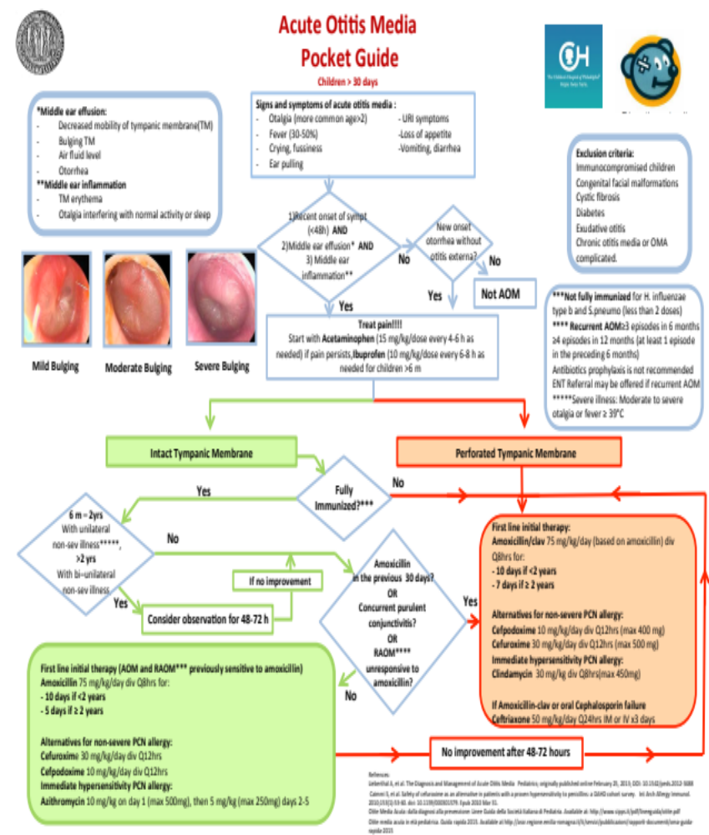

ATTACHMENT 3
Pharyngitis Clinical Pathway
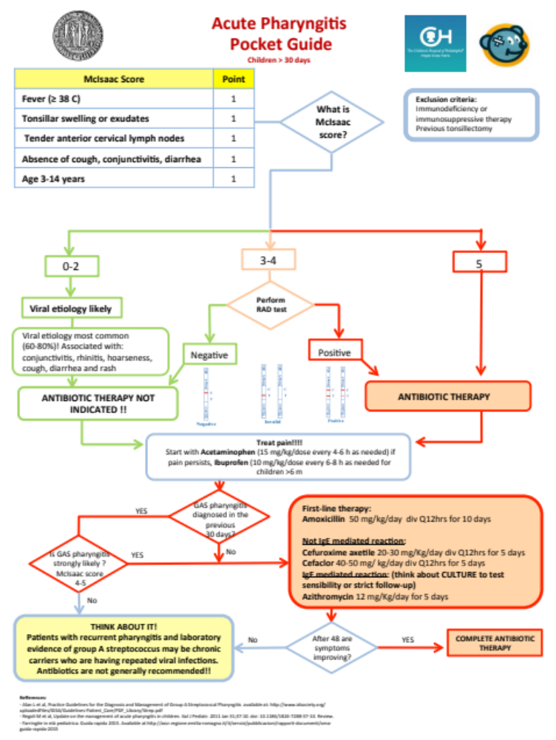
ATTACHMENT 4

Community-Acquired Penumonia Clinical Pathway

